**National Forensic Sciences University**

**School of Cyber security and Digital Forensics**



***Subject: Advance Java***

***Topic:Practical Report for Labs***

**Submitted to: Bharat Buddhev Sir**

**Submitted by: Krishita Sanjay Choksi**

**(101CTBMCS2122005)**

**Submission Date: 1/7/2024**

LAB1:

L.1 See and study our network architecture by using various network commands such as ping,traceroute, tracert, nslookp, ipconfig,ifconfig, pathping, netstat, arp, who, whois, ncat, nmap . And understand and explain the output of each network commands. Most commands are on Ubuntu so create virtual machine and install Ubuntu in windows or install dual boot and run and see network commands on both windows and Ubuntu

**1.traceroute / tracert**: These commands are used to trace the route that packets take from your computer to a destination host. They send packets with increasingly higher TTL (Time To Live) values and observe the responses to determine the path taken. Each hop along the route is listed along with its IP address and response time.

Some Options:

• -h [max_hops]: Sets maximum hops to trace

• -w [timeout]: Sets maximum time to wait for each reply

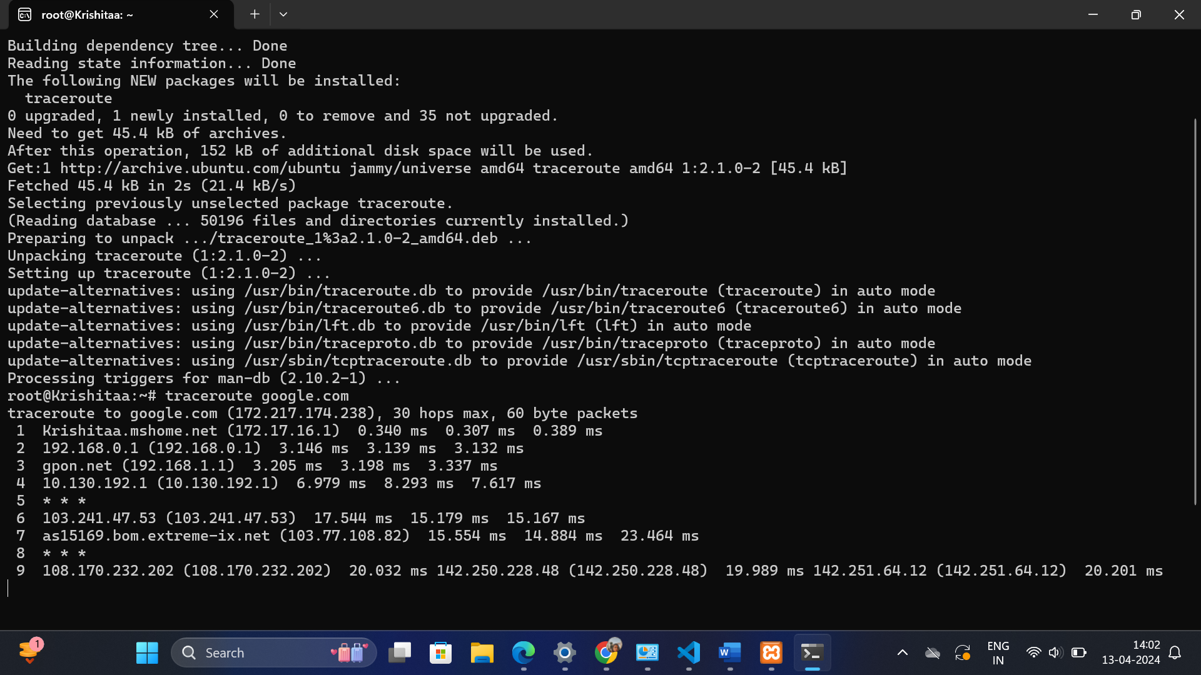

2) **ping**: This command is used to test the reachability of a host on an IP network. It sends ICMP Echo Request packets to the target host and waits for ICMP Echo Reply packets. If the target host is reachable, it will respond to the ping requests.

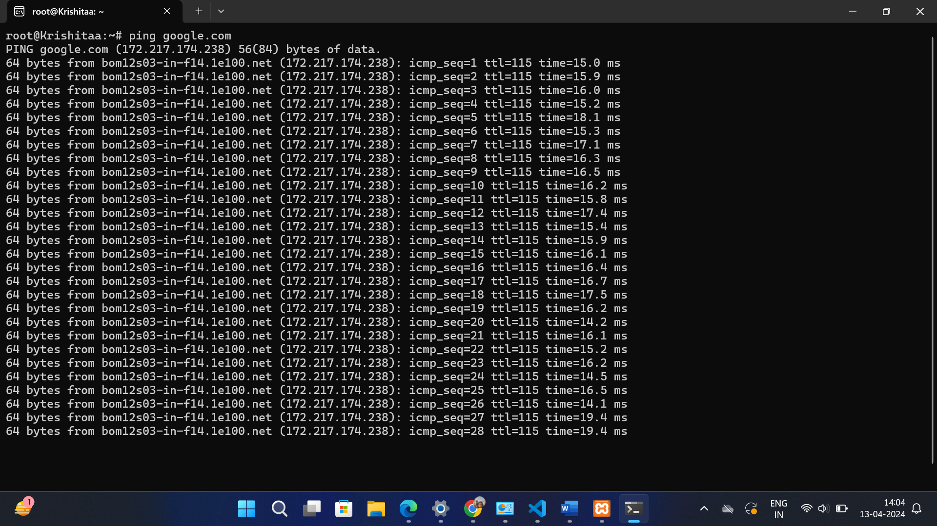

3) nslookup: This command is used to query DNS (Domain Name System) servers to obtain domain name or IP address information. It can be used to look up the IP address associated with a domain name or vice versa.

Some options:

• server [DNS server]: Specifies the DNS server to use for queries

• ls [domain]: Lists information about the DNS domain (zone transfer)

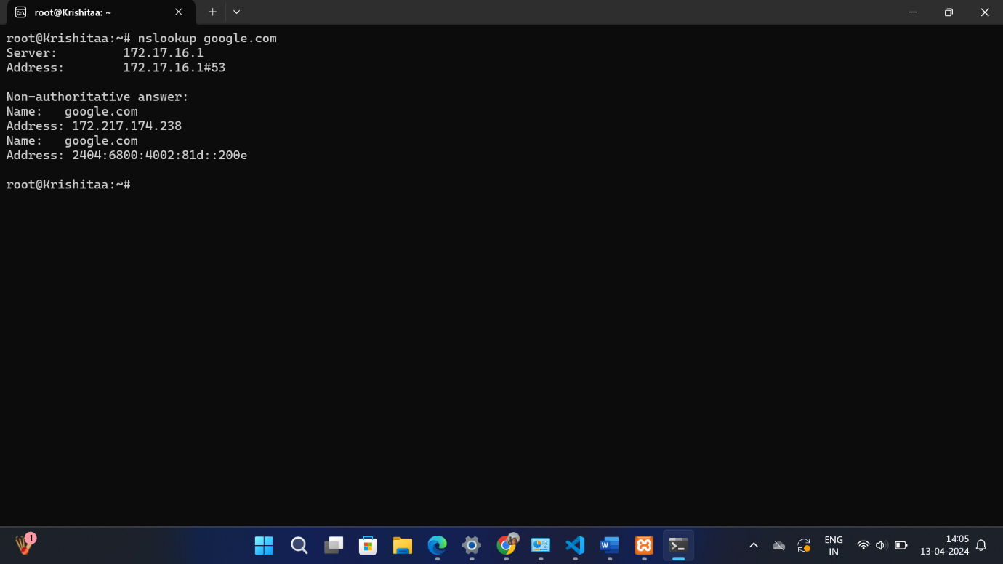

4) **ifconfig**: On Unix-like systems (e.g., Linux, macOS), this command displays the configuration of network interfaces. It shows details similar to **ipconfig** on Windows.

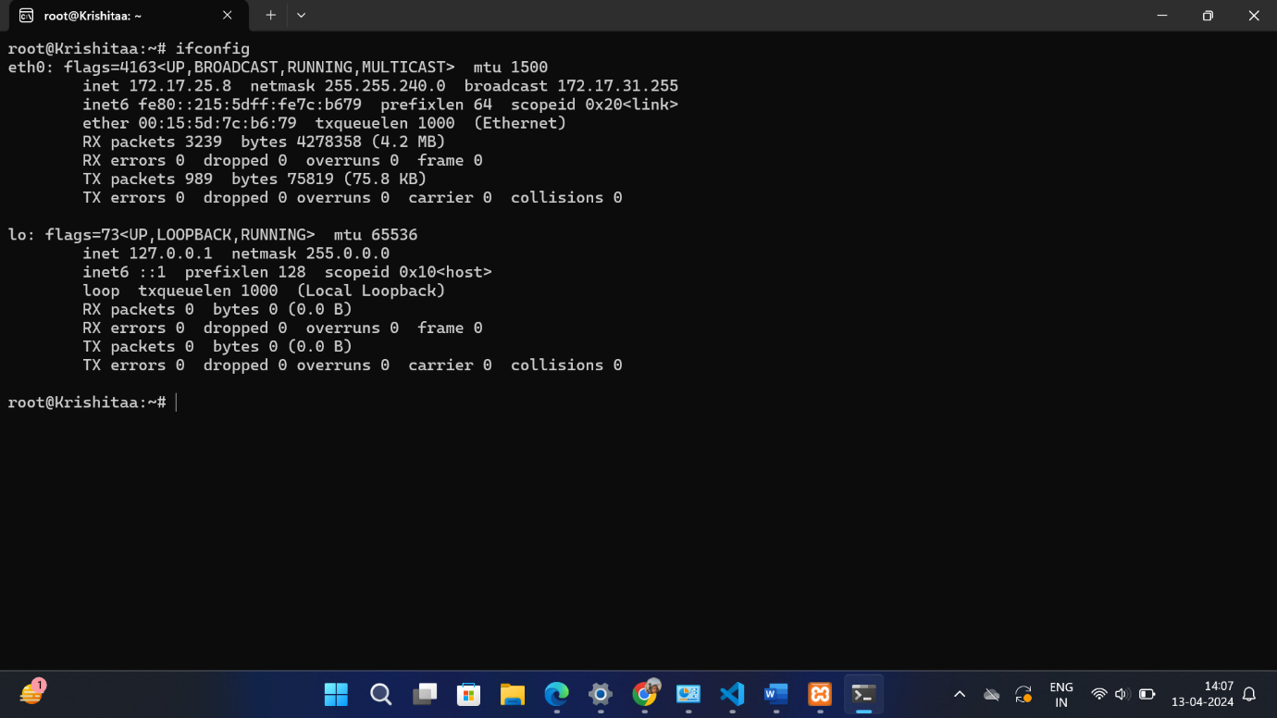

5)netstat

**netstat**: This command displays network connections, routing tables, interface statistics, masquerade connections, and multicast memberships. It shows active TCP connections, listening ports, and more.

Options:

• netstat: Displays active network connections

• -a: Shows all connections

• -n: Displays numerical addresses and port numbers

• -r: Displays the routing table

• -s: Displays statistics for various network protocols

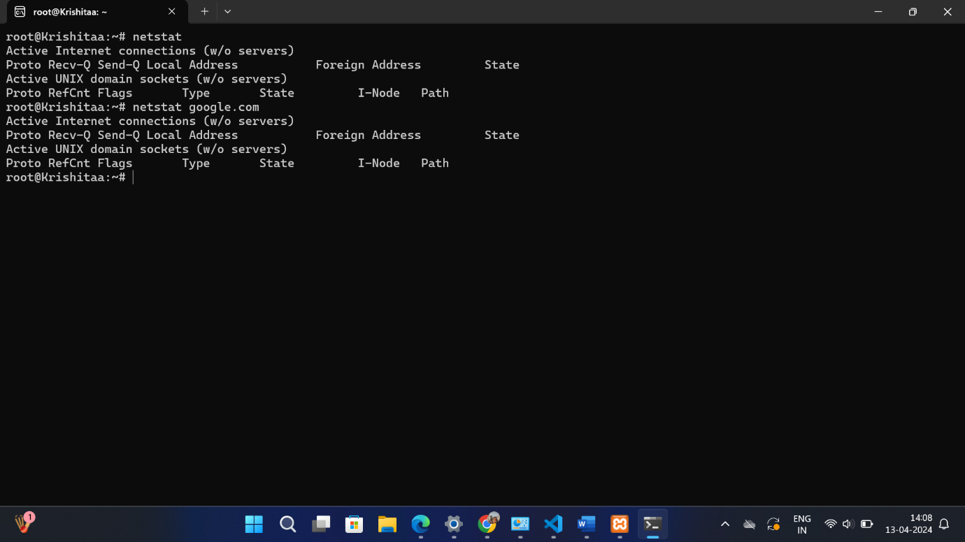

6)ARP:

**arp**: This command displays and modifies the Address Resolution Protocol (ARP) cache, which maps IP addresses to MAC addresses on your local network.

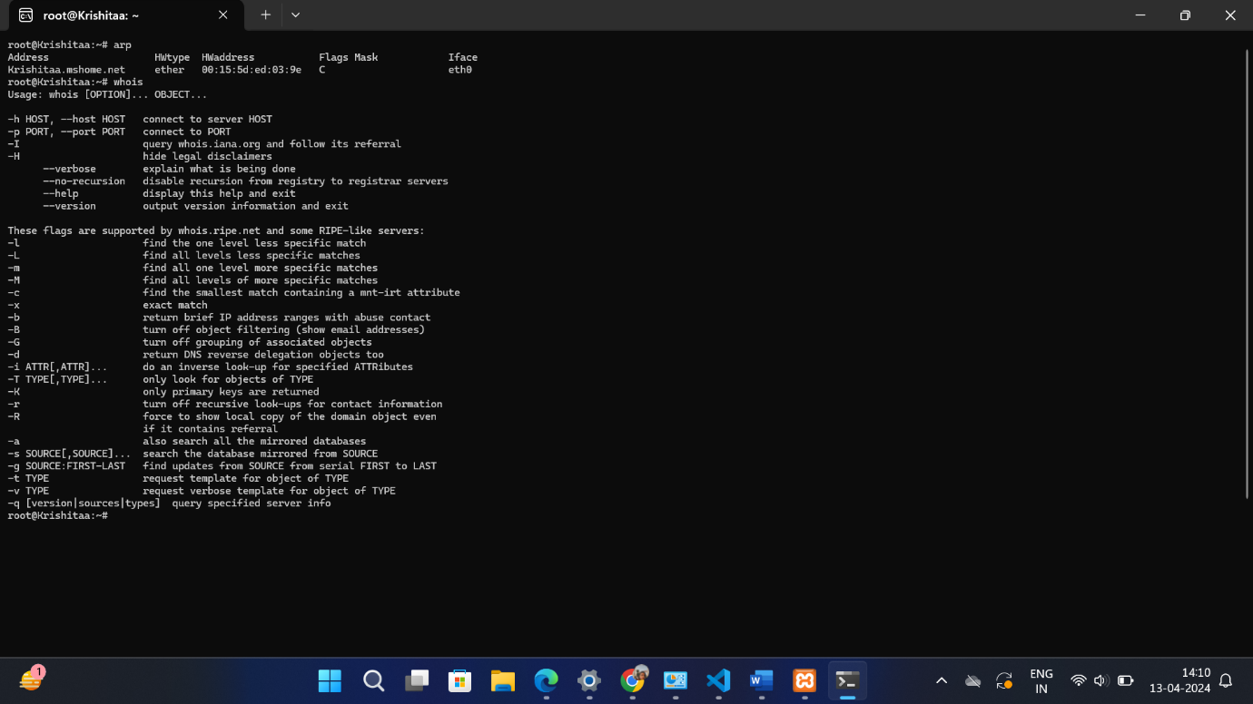

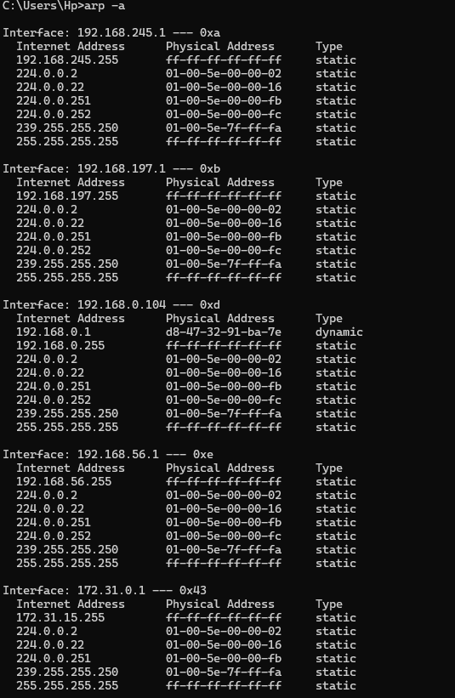

7)nmap:

**nmap**: This is a powerful network scanning tool used to discover hosts and services on a computer network. It can perform host discovery, port scanning, version detection, and more.

Can scan

➔ single target: nmap [target]

➔ multiple target: nmap [target1] [target2]

➔ range of ip address to scan: nmap [range of IP]

➔ scan entire subnet: nmap [Network/CIDR]

➔ scan list of targets: nmap -iL list.txt

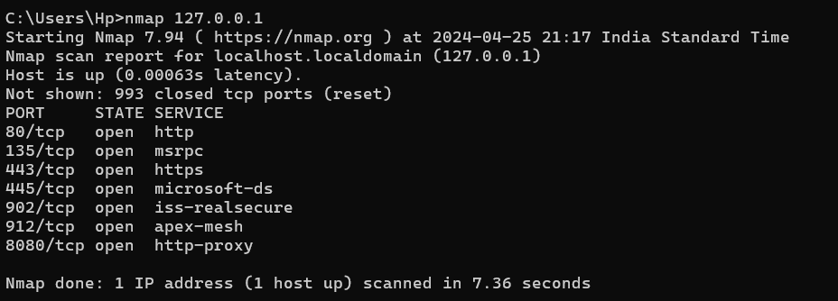

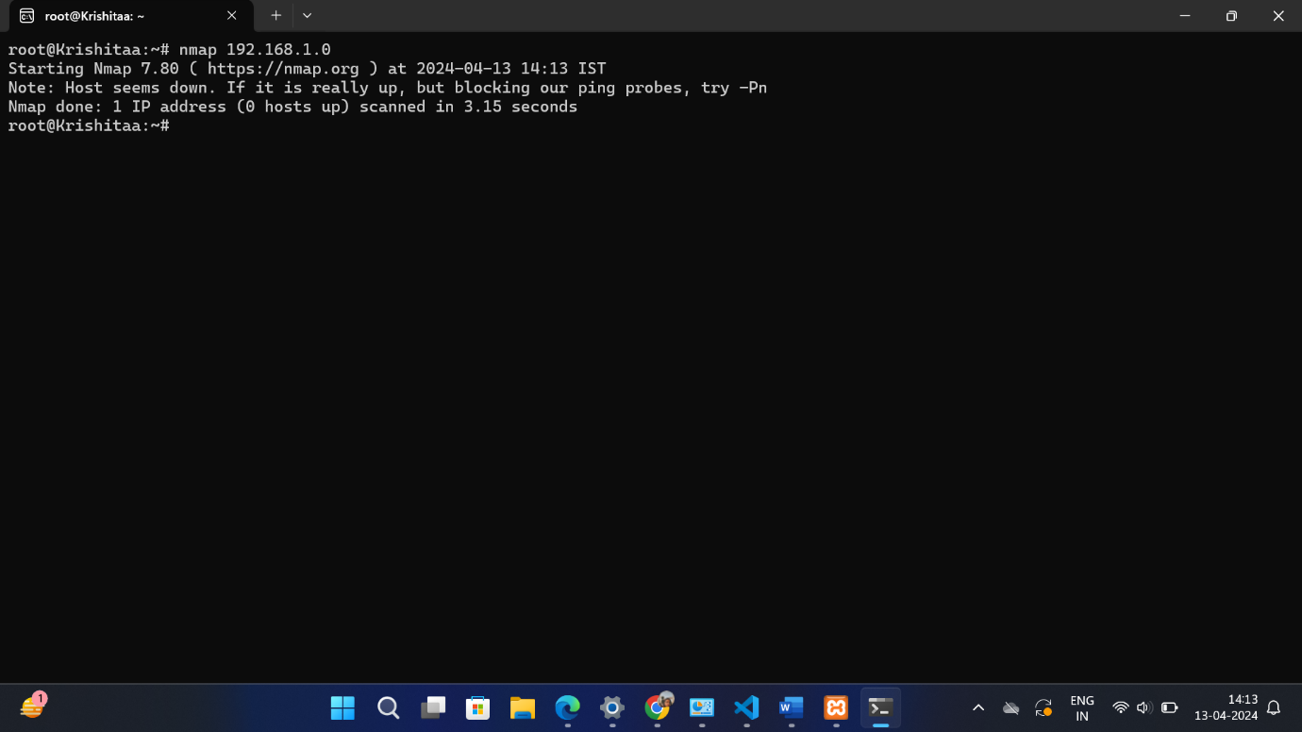

8)who and whois:

**who**: This command shows information about users who are currently logged in to the system.

It is mostly used for:

➔ Checking who is currently using the system.

➔ Verifying active user sessions.

➔ Identifying the terminal or device each user is logged into.

➔ Monitoring login times.

**whois**: This command queries a WHOIS database to retrieve information about the owner of a domain name or an IP address range. It provides details such as domain registrar, contact information, and more.

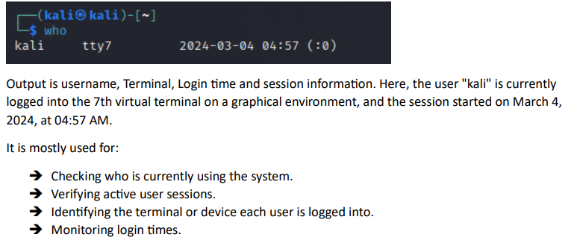

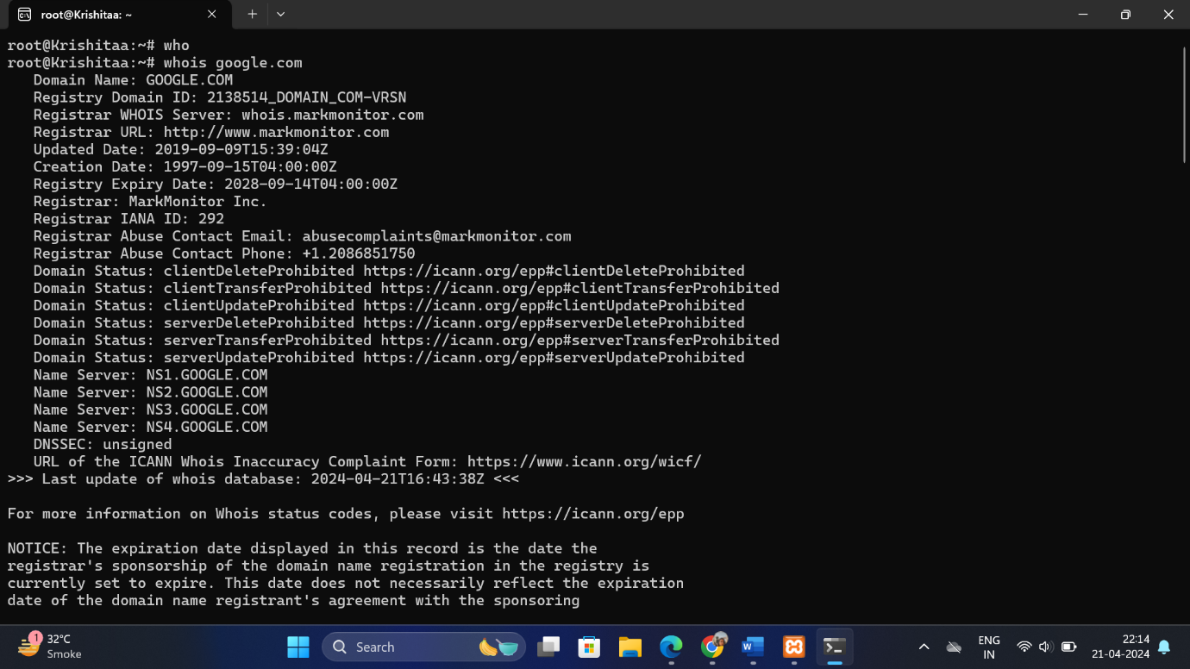

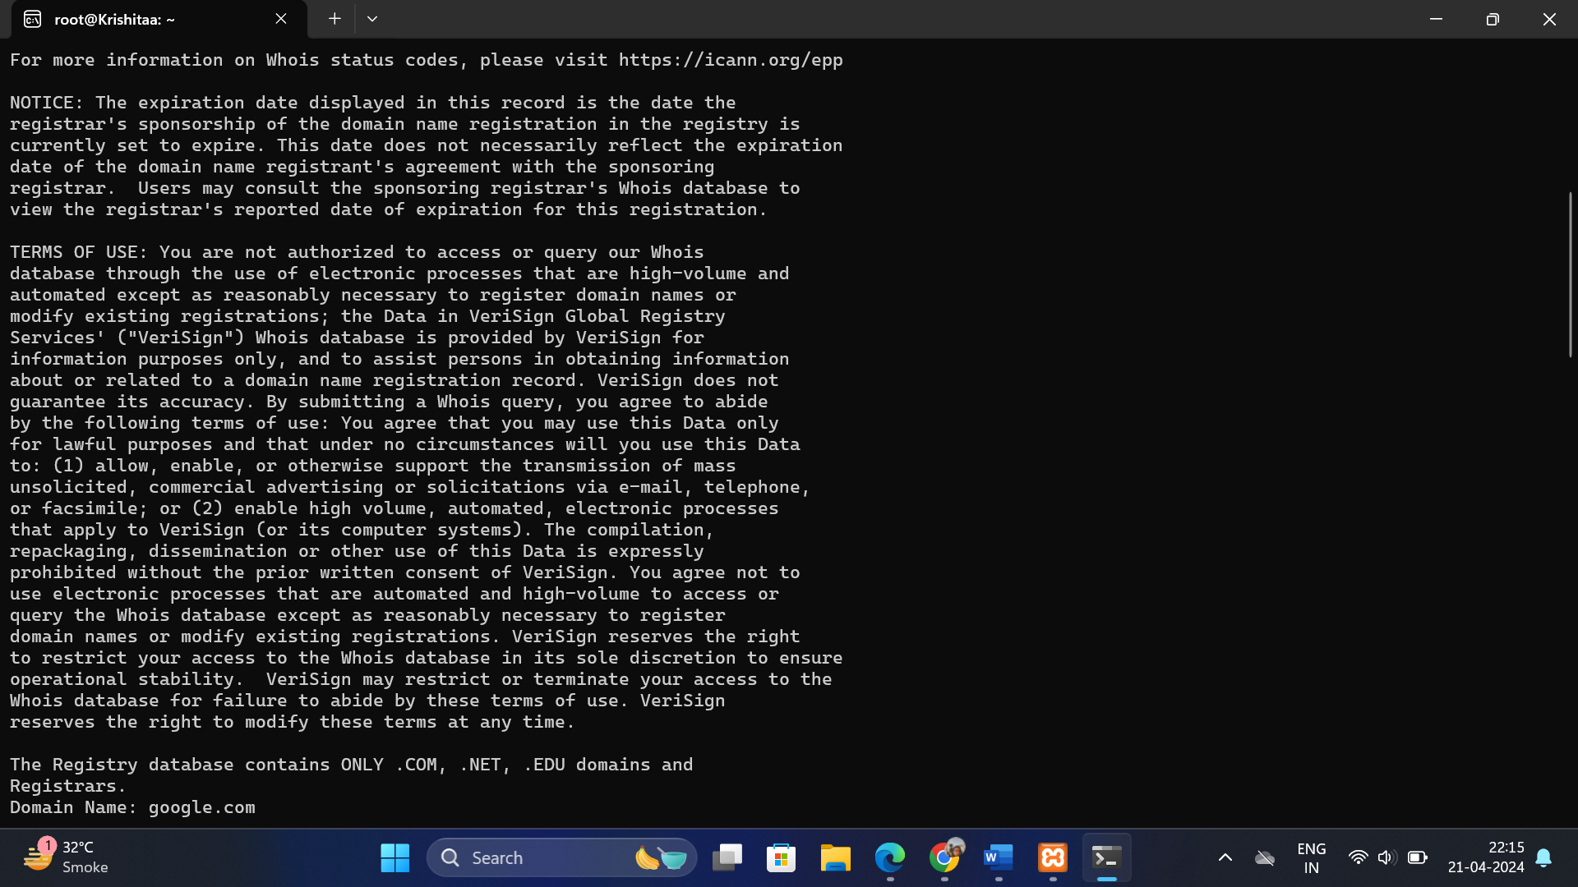

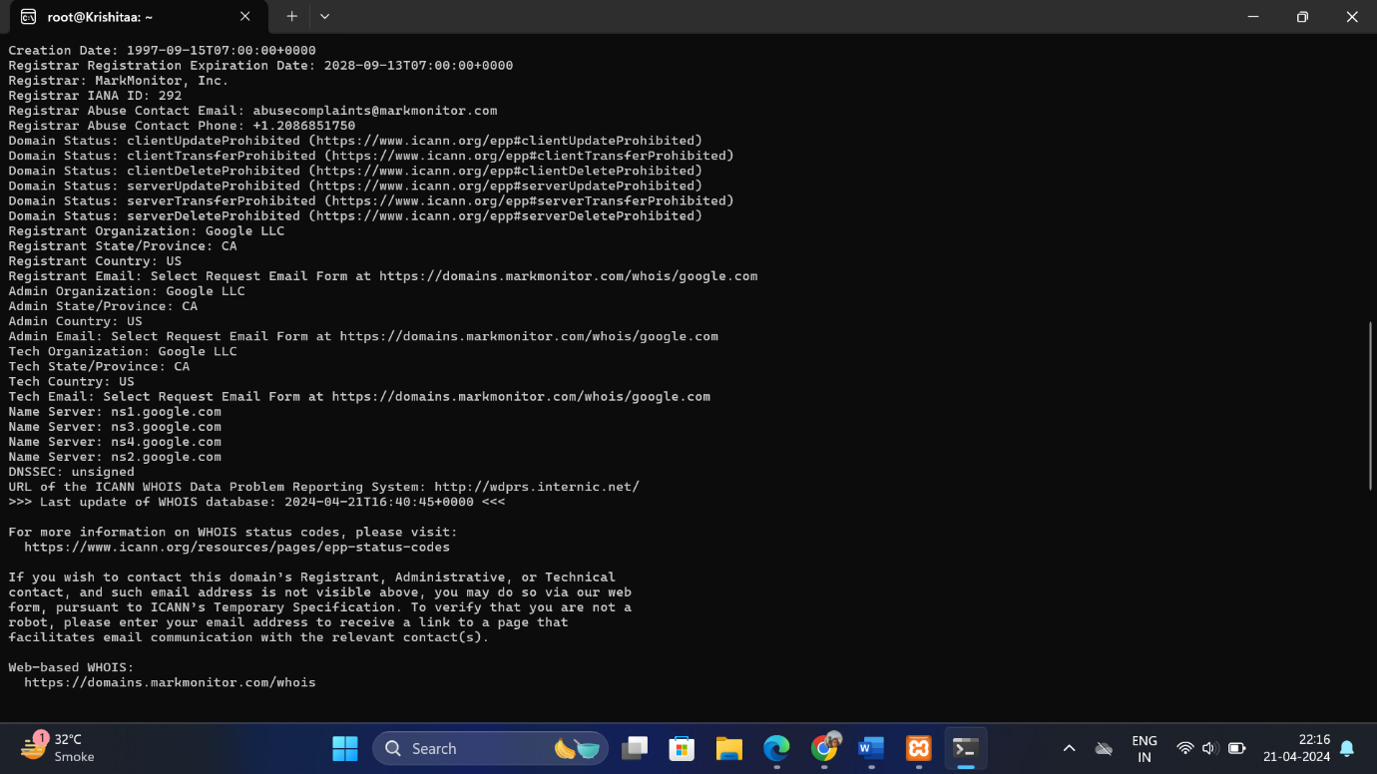

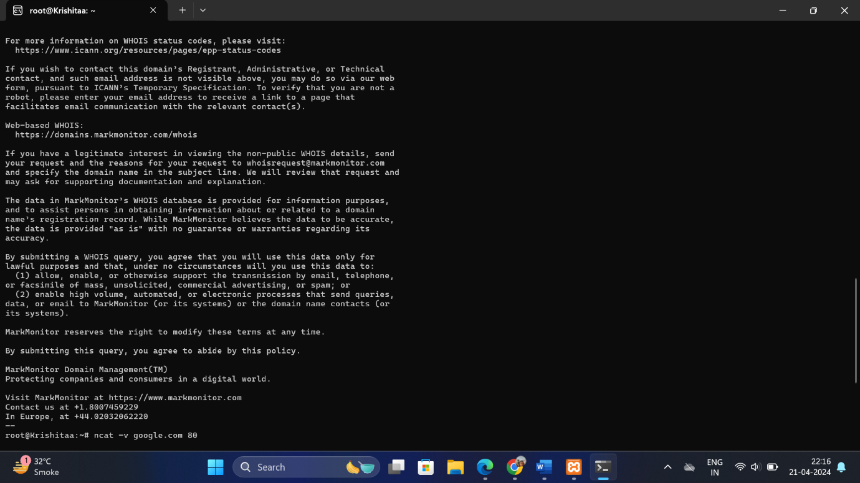

9)ncat:

**ncat**: This is a networking utility similar to the traditional **netcat** tool. It can read and write data across network connections using TCP or UDP protocols. It's often used for testing and debugging network services.

1) nc -lvp <port-number> > file_name

This command makes the machine act as server to listen the requests and respond. By the

command

“> file_name” it adds the data sent from the client to the file

2) nc <ip-address> <port-number> < file_name

This command makes machine act as a client to send requests to the server. By the

command

“< file_name” it sends the file to the server. And Ip address is of the listening machine

Here the file created in ubuntu sample.txt is transferred to kali linux and stored as file.txt

through netcat. We can do the vice-versa as well.

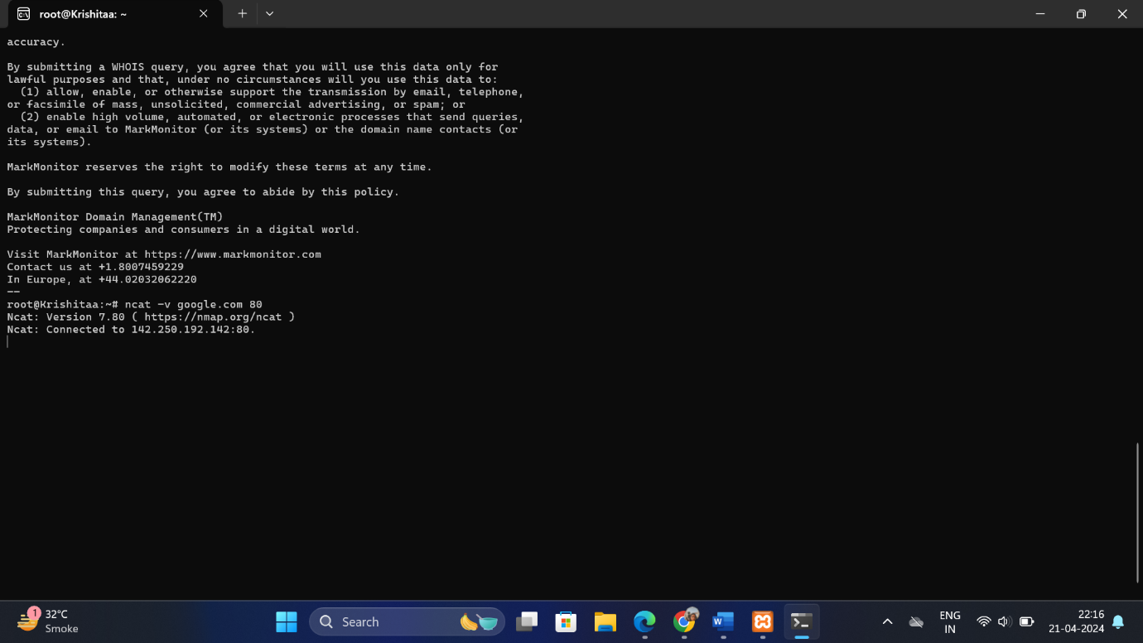

10)ipconfig:

**ipconfig**: On Windows systems, this command displays the IP configuration for all network interfaces. It shows details such as IP address, subnet mask, default gateway, and DNS servers.

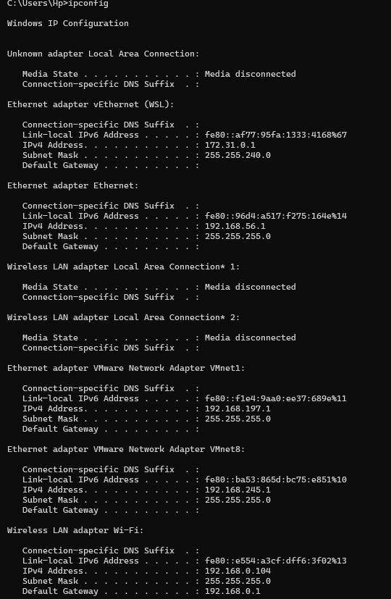

11)pathping

It is the combination of traceroute and ping. Like ping, pathping sends a series of packets to the

destination. It measures the round-trip time for each packet. Similar to traceroute, pathping displays

the route the packets take to reach the destination. It identifies all the intermediate routers or hops

along the way. For each hop, pathping conducts a series of ping measurements over a period of time,

collecting statistics. It also provides insights into the quality of each hop's connection.

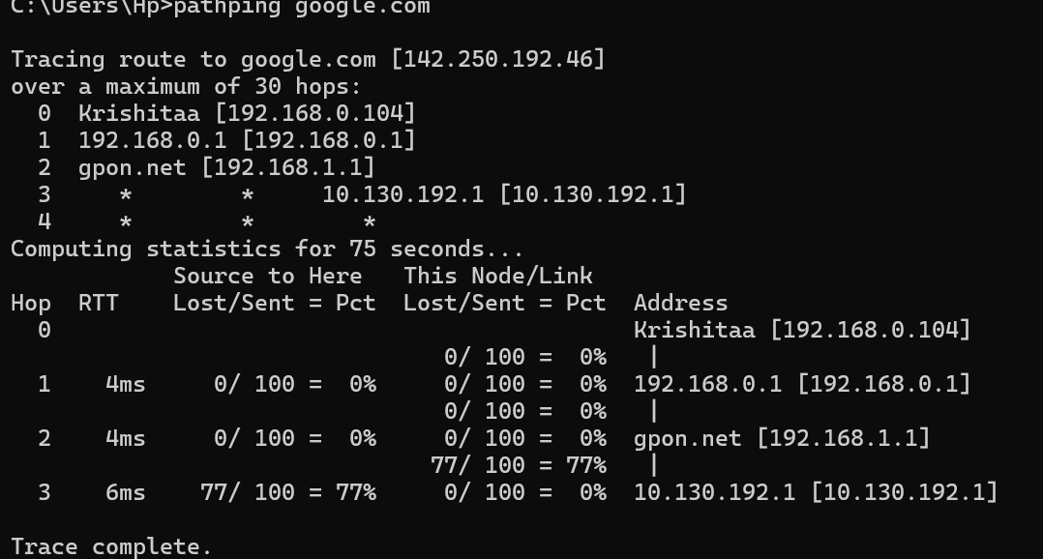

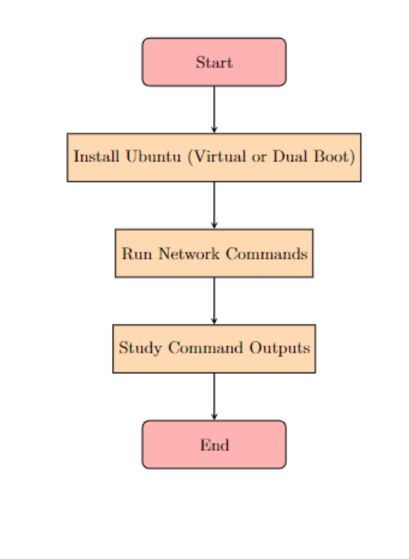

/////////////////////////////////////////////////////////////////////////////////////////////////////

LAB2:

Install java JDK and JRE both on Ubuntu and windows both and configure the path both in both system and try to understand the all executable programs and understand java commands. Install tomcat and understand server side programming.

### Problem Statement

#### Task 1: Install Java JDK and JRE on Ubuntu and Windows

The objective is to install Java Development Kit (JDK) and Java Runtime Environment (JRE) on both Ubuntu and Windows operating systems.

#### Task 2: Configure Java Path on Ubuntu and Windows

After installing JDK and JRE, configure the environment variables (path) on both operating systems to make Java executable programs and commands accessible globally.

#### Task 3: Understand Executable Programs and Java Commands

Explore and understand the executable programs (like javac, java) provided by JDK and JRE. Learn and practice basic Java commands.

#### Task 4: Install Tomcat and Understand Server-Side Programming

Install Apache Tomcat server and gain an understanding of server-side programming concepts.

### Output

#### Task 1: Install Java JDK and JRE on Ubuntu and Windows

#### Problem Statement Breakdown:

1. **Installation**:
   * **Ubuntu**: Install JDK and JRE using apt package manager or manual download.
   * **Windows**: Download JDK and JRE from Oracle's website and run the installer.

#### Expected Output:

* **Installed JDK and JRE**:
  + Verify successful installation by checking the installed directories (/usr/lib/jvm/ on Ubuntu, C:\Program Files\Java on Windows).

#### Task 2: Configure Java Path on Ubuntu and Windows

#### Problem Statement Breakdown:

1. **Configuration**:
   * **Ubuntu**: Set JAVA_HOME and add JDK bin directory to PATH in .bashrc or /etc/environment.
   * **Windows**: Set JAVA_HOME and update PATH in Environment Variables through Control Panel.

#### Expected Output:

* **Configured Java Path**:
  + Verify by opening a terminal (Ubuntu) or Command Prompt (Windows) and running java -version and javac -version commands to ensure Java commands are recognized globally.

#### Task 3: Understand Executable Programs and Java Commands

#### Problem Statement Breakdown:

1. **Executable Programs**:
   * Explore javac (Java Compiler) and java (Java Interpreter) programs.
   * Learn basic Java commands (javac, java, jar, etc.) and their usage.

#### Expected Output:

* **Java Commands**:
  + Practice compiling and running a simple Java program using javac and java commands.
  + Understand how to package Java applications using jar command.

#### Task 4: Install Tomcat and Understand Server-Side Programming

#### Problem Statement Breakdown:

1. **Installation**:
   * Download and install Apache Tomcat server on both Ubuntu and Windows.
   * Configure Tomcat to run on a specific port (e.g., 8080).

#### Expected Output:

* **Installed Tomcat**:
  + Verify installation by accessing Tomcat homepage (http://localhost:8080) in a web browser.
  + Understand server-side programming concepts such as servlets, JSP (JavaServer Pages), and deploying web applications.

### Example Output Flow:

1. **Installation and Configuration**:
   * Install JDK and JRE on Ubuntu using apt.
   * Configure JAVA_HOME and PATH in .bashrc.
   * Verify with java -version and javac -version commands.
2. **Executable Programs and Java Commands**:
   * Compile and run a basic Java program using javac and java commands.
   * Package the program into a JAR file using jar command.
3. **Tomcat Installation and Server-Side Programming**:
   * Download and install Tomcat on both Ubuntu and Windows.
   * Start Tomcat server and access its homepage (http://localhost:8080).
   * Explore server-side programming capabilities using servlets and JSP.

### Conclusion

This setup provides a structured approach to installing JDK and JRE on Ubuntu and Windows, configuring their paths, understanding Java executable programs and commands, and installing Tomcat for server-side programming. It helps in gaining hands-on experience with Java development environments and server-side technologies, preparing for further Java application development and web programming tasks.

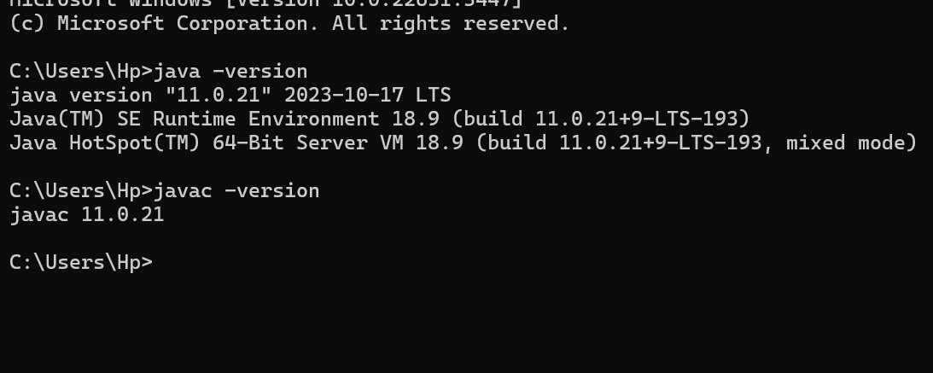

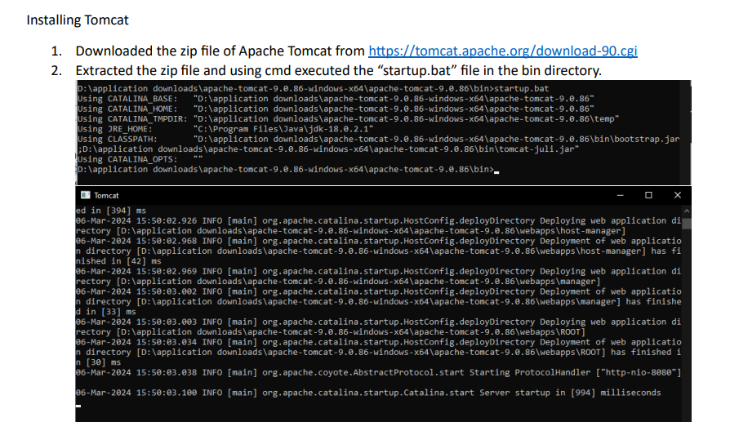

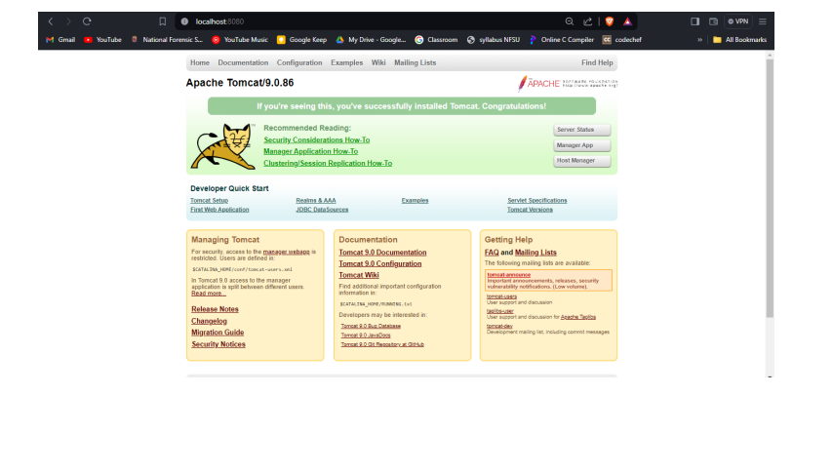

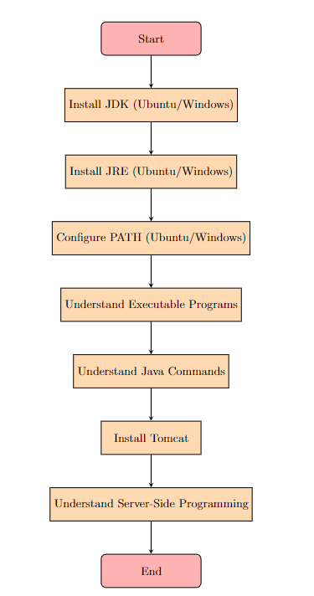

///////////////////////////////////////////////////////////////////////////////////////////////////////////

LAB3:

Install Eclipse or Netbeans and configure basic java and J2EE tomcat server configure and develop basic java and HTML program in either Eclipse or Netbeans IDE

### Problem Statement

#### Task 1: Install Eclipse or NetBeans IDE

The objective is to install either Eclipse or NetBeans IDE on your system. These IDEs will serve as development environments for Java and J2EE applications.

#### Task 2: Configure Basic Java and J2EE with Tomcat Server

After installing the IDE, configure it to develop Java and J2EE applications using the Apache Tomcat server.

#### Task 3: Develop Basic Java Program

Create a simple Java program in the IDE that demonstrates basic functionality.

#### Task 4: Develop Basic HTML Program

Create a basic HTML program in the IDE to understand web development capabilities.

### Output

#### Task 1: Install Eclipse or NetBeans IDE

#### Problem Statement Breakdown:

1. **Installation**:
   * Download and install either Eclipse or NetBeans from their official websites or through package managers (like apt for Linux, or direct download for Windows).
   * Follow installation prompts and ensure the IDE is set up correctly on your system.

#### Expected Output:

* **Installed IDE**:
  + Successfully installed Eclipse or NetBeans IDE on your system.
  + Ready to proceed with configuring for Java and J2EE development.

#### Task 2: Configure Basic Java and J2EE with Tomcat Server

#### Problem Statement Breakdown:

1. **Configure IDE**:
   * Open Eclipse or NetBeans IDE.
   * Set up JDK (Java Development Kit) if not already configured.
   * Configure Apache Tomcat server integration with the IDE for J2EE development.

#### Expected Output:

* **Configured IDE**:
  + IDE configured with JDK and Apache Tomcat server.
  + Able to create and run Java and J2EE projects using the integrated Tomcat server.

#### Task 3: Develop Basic Java Program

#### Problem Statement Breakdown:

1. **Create Java Project**:
   * Develop a simple Java program (e.g., Hello World) in the IDE.
   * Compile and execute the program to ensure functionality.

#### Expected Output:

* **Java Program**:
  + Successfully created and executed a basic Java program.
  + Output displayed in the console or as specified in the program.

#### Task 4: Develop Basic HTML Program

#### Problem Statement Breakdown:

1. **Create HTML Project**:
   * Develop a basic HTML program (e.g., Hello World webpage) in the IDE.
   * Preview the HTML webpage in a web browser to ensure functionality.

#### Expected Output:

* **HTML Program**:
  + Successfully created and viewed a basic HTML webpage.
  + Content displayed correctly in the web browser.

### Example Output Flow:

1. **Installation and Configuration**:
   * Installed Eclipse IDE.
   * Configured Eclipse with JDK and integrated Apache Tomcat server.
2. **Develop Java Program**:
   * Created a Java project in Eclipse.
   * Developed a simple Java program (e.g., printing "Hello World") and executed it successfully.
3. **Develop HTML Program**:
   * Created an HTML project in Eclipse.
   * Developed a basic HTML webpage (e.g., displaying "Hello, HTML!") and previewed it in a web browser.

### Conclusion

This setup provides a structured approach to installing either Eclipse or NetBeans IDE, configuring them for Java and J2EE development with Apache Tomcat server, and developing basic Java and HTML programs. It helps familiarize with IDE functionalities and sets the stage for more advanced Java and web development tasks in the chosen environment.

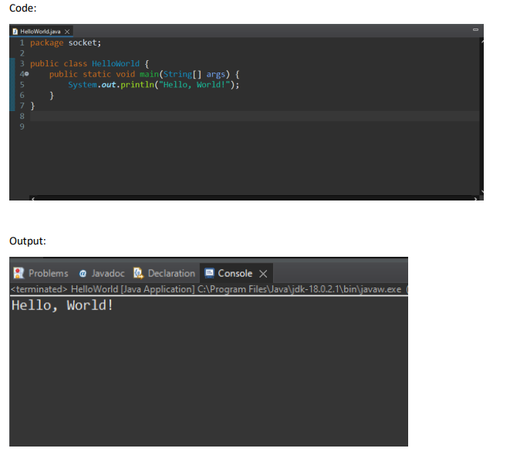

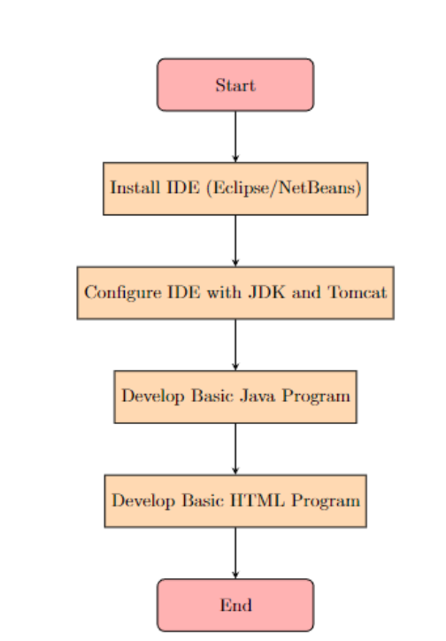

/////////////////////////////////////////////////////////////////////////////////////////////////////

LAB4:

Develop Java based Login application and provide hard coded login name and password along with remember facility and show successful login and failure login both cases

### Problem Statement

The objective is to create a Java application for user authentication with the following features:

1. **Login Interface**:
   * A graphical interface (GUI) or command-line interface (CLI) where users can enter their username and password.
   * Option to remember login credentials for future sessions.
2. **Authentication Logic**:
   * Implement hardcoded login credentials (username and password) within the application.
   * Validate user input against these credentials.
   * Display appropriate messages for successful and failed login attempts.

### Output

#### Problem Statement Breakdown:

1. **Login Interface**:
   * Develop a Java program (LoginApplication) with a GUI or CLI for user interaction.
   * Include fields for username, password, and a checkbox for remembering login credentials.
2. **Authentication Logic**:
   * Hardcode a set of valid username and password pairs (e.g., username: admin, password: admin123).
   * Implement logic to compare user input against these hardcoded credentials.
   * Provide feedback messages for both successful and failed login attempts.

### Expected Output

#### Successful Login Scenario:

* **LoginApplication**:
  + **GUI/CLI**:
    - Display fields for username, password, and a remember checkbox.
  + **Authentication Logic**:
    - If user enters correct credentials (username: admin, password: admin123):
      * Display a success message like "Login successful! Welcome, [Username]".
      * Optionally, save login credentials if the remember checkbox is selected.

#### Failed Login Scenario:

* **LoginApplication**:
  + **GUI/CLI**:
    - Display fields for username, password, and a remember checkbox.
  + **Authentication Logic**:
    - If user enters incorrect credentials:
      * Display an error message like "Invalid username or password. Please try again."
    - Clear fields for retry or provide an option to reset.

### Example Output Flow:

1. **LoginApplication**:
   * Launch the application with a login interface.
   * User enters username as "admin" and password as "admin123".
   * Clicks on the login button.
2. **Successful Login**:
   * Application verifies the credentials.
   * Displays "Login successful! Welcome, admin" message.
   * Optionally, remembers the login details for future sessions if the remember checkbox is selected.
3. **Failed Login**:
   * User enters incorrect password or username.
   * Application displays "Invalid username or password. Please try again."
   * User can retry by clearing fields or resetting the form.

### Conclusion

This setup illustrates the development of a simple yet effective Java-based login application with hardcoded credentials and a remember facility. It demonstrates fundamental user authentication principles and provides a user-friendly interface for interacting with the application.

Code:

Package krishita.lab4;

import java.util.Scanner;

public class Lab4 {

// Hard-coded username and password

private static final String USERNAME = "krishita";

private static final String PASSWORD = "baps1710";

public static void main(String[] args) {

Scanner scanner = new Scanner(System.in);

System.out.println("Welcome to Login Application!");

boolean loggedIn = false;

boolean rememberMe = false;

// Check if the user wants to be remembered

System.out.println("Do you want to be remembered? (yes/no)");

String rememberChoice = scanner.nextLine().trim().toLowerCase();

if (rememberChoice.equals("yes")) {

rememberMe = true;

}

// Login loop

while (!loggedIn) {

// Prompt for username and password

System.out.print("Enter username: ");

String usernameInput = scanner.nextLine().trim();

System.out.print("Enter password: ");

String passwordInput = scanner.nextLine().trim();

// Check if login credentials are correct

if (usernameInput.equals(USERNAME) && passwordInput.equals(PASSWORD)) {

System.out.println("Login successful!");

loggedIn = true;

} else {

System.out.println("Invalid username or password. Please try again.");

}

}

// Remember the user if selected

if (rememberMe) {

System.out.println("You will be remembered.");

}

// Close scanner

scanner.close();

}

}

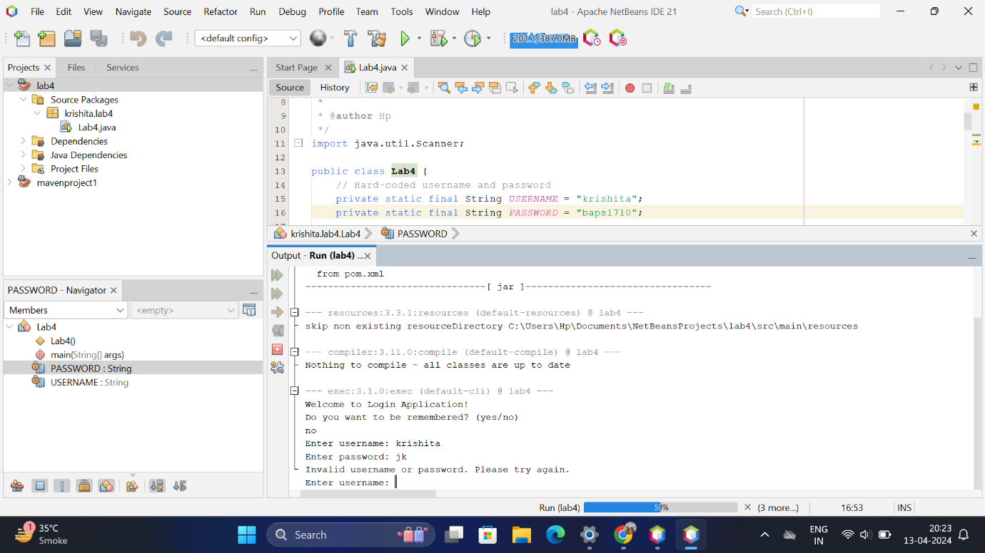

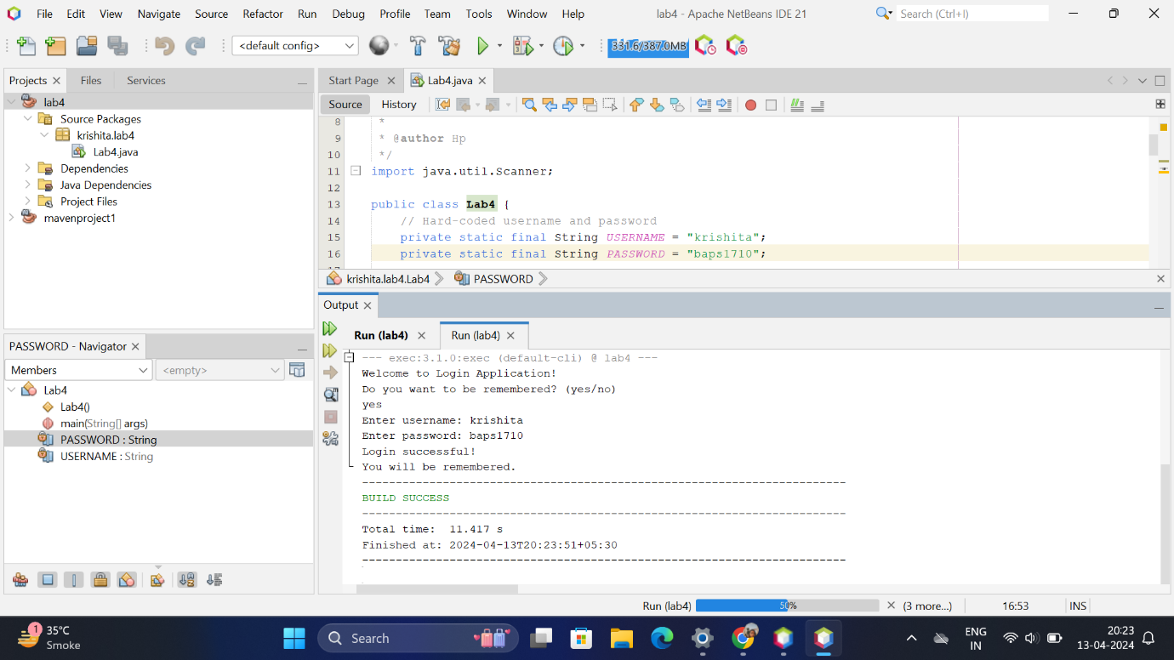

OR:(FOR LAB4)

Code:

import java.util.ArrayList;

import java.util.Scanner;

public class LoginApplication {

// login credentials list

static ArrayList<String> usernames = new ArrayList<String>();

static ArrayList<String> passwords = new ArrayList<String>();

private static boolean rememberMe = false;

private static String loggedInUsername = "";

public static void main(String[] args) {

//Hardcoded username and password

usernames.add("admin");

passwords.add("password");

Scanner scanner = new Scanner(System.in);

System.out.println("Welcome to Login Application!");

while (true) {

System.out.println("\nOptions:");

System.out.println("1. Login");

System.out.println("2. Register");

System.out.println("3. Logout");

System.out.println("4. Exit");

System.out.print("Choose an option: ");

int choice = scanner.nextInt();

scanner.nextLine(); // Consume newline

switch (choice) {

case 1:

login(scanner);

break;

case 2:

register(scanner);

break;

case 3:

logout();

break;

case 4:

System.out.println("Exiting...");

scanner.close();

System.exit(0);

default:

System.out.println("Invalid option. Please try again.");

}

}

}

// Method to handle login

private static void login(Scanner scanner) {

if (!loggedInUsername.isEmpty()) {

System.out.println("You are already logged in as " + loggedInUsername);

return;

}

System.out.print("Enter your username: ");

String enteredUsername = scanner.nextLine();

System.out.print("Enter your password: ");

String enteredPassword = scanner.nextLine();

// Validate credentials

if (validateCredentials(enteredUsername, enteredPassword)) {

loggedInUsername = enteredUsername;

System.out.println("Login successful!");

// Remember login if requested

System.out.print("Do you want to remember your login? (yes/no): ");

String rememberChoice = scanner.nextLine();

if (rememberChoice.equalsIgnoreCase("yes")) {

rememberMe = true;

} else {

rememberMe = false;

}

} else {

System.out.println("Login failed. Incorrect username or password.");

}

}

// Method to handle registration

private static void register(Scanner scanner) {

if (!loggedInUsername.isEmpty()) {

System.out.println("You are already logged in as " + loggedInUsername);

return;

}

System.out.print("Enter a new username: ");

String newUsername = scanner.nextLine();

System.out.print("Enter a new password: ");

String newPassword = scanner.nextLine();

// store the new username and password in the list

usernames.add(newUsername);

passwords.add(newPassword);

System.out.println("Registration successful! You can now login with your new credentials.");

}

// Method to handle logout

private static void logout() {

if (!loggedInUsername.isEmpty()) {

System.out.println("Logging out user: " + loggedInUsername);

if (!rememberMe) {

loggedInUsername = "";

}

} else {

System.out.println("You are not currently logged in.");

}

}

// Method to validate entered credentials

private static boolean validateCredentials(String username, String password) {

for (int i = 0; i < usernames.size(); i++) {

if (username.equals(usernames.get(i)) && password.equals(passwords.get(i))) {

return true;

}

}

return false;

}

}

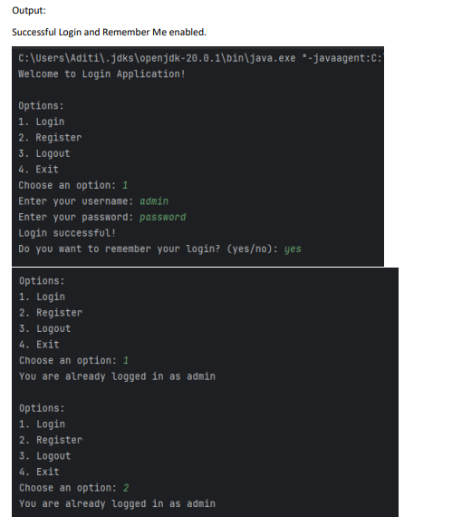

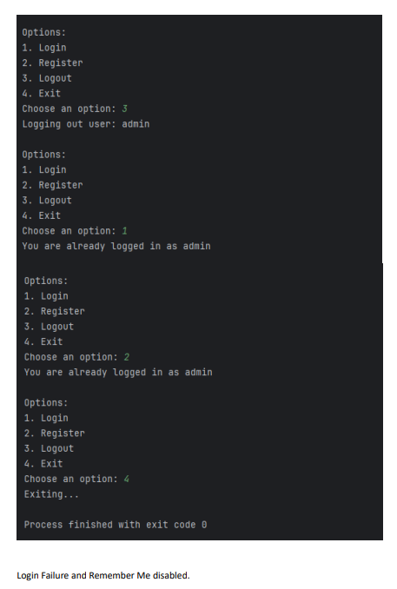

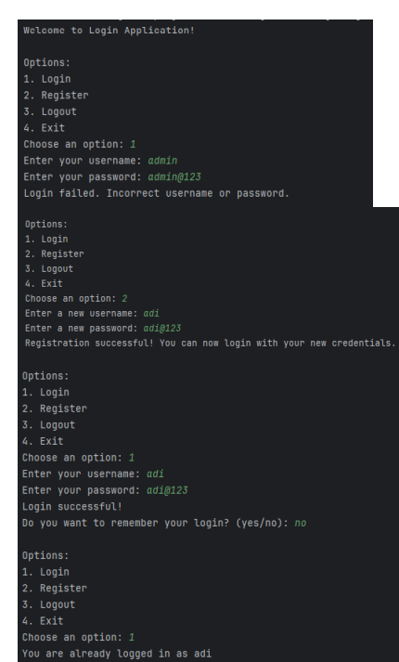

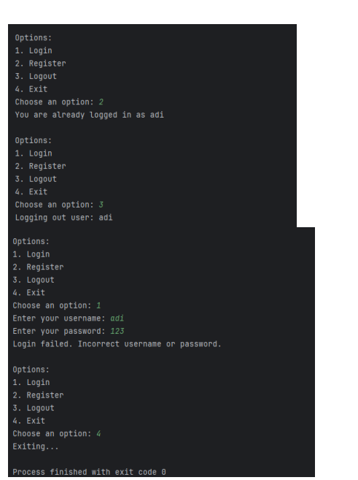

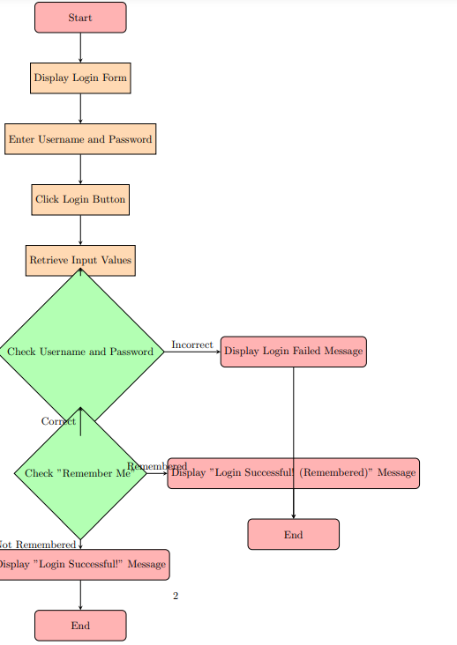

//////////////////////////////////////////////////////////////////////////////////////////////////////////

LAB5:

Develop Java programs using Java.io classes for displaying the contents of text file and also write java Program for copying the file facility.

### Problem Statement

#### Task 1: Display Contents of a Text File

The objective is to create a Java program that reads and displays the contents of a text file using java.io classes.

#### Task 2: File Copying Facility

The goal is to develop a Java program that copies a file from one location to another using java.io classes.

### Output

#### Task 1: Display Contents of a Text File

#### Problem Statement Breakdown:

1. **File Reading**:
   * Implement a Java program (ReadFileContents) that reads a specified text file.
   * Use FileReader and BufferedReader from java.io to open and read the file.
   * Display each line of the file content on the console or output it to another destination.

#### Expected Output:

* **ReadFileContents**:
  + **File Reading**:
    - Open the specified text file (example.txt).
    - Use FileReader to create a reader object for the file.
    - Use BufferedReader for efficient reading, using methods like readLine() to read each line.
    - Print each line of the file's content to the console or store it for further processing.

#### Example Output Flow:

1. **ReadFileContents**:
   * Open example.txt using FileReader and BufferedReader.
   * Read and display each line of text from example.txt on the console.

### Task 2: File Copying Facility

#### Problem Statement Breakdown:

1. **File Copying**:
   * Implement a Java program (FileCopy) that copies a file from a source location (sourceFile.txt) to a destination location (destinationFile.txt).
   * Use FileInputStream, FileOutputStream, and BufferedInputStream, BufferedOutputStream from java.io for efficient file copying.

#### Expected Output:

* **FileCopy**:
  + **File Copying**:
    - Open sourceFile.txt using FileInputStream and create a reader object.
    - Open destinationFile.txt using FileOutputStream and create a writer object.
    - Use BufferedInputStream and BufferedOutputStream for efficient data transfer between files.
    - Copy contents byte by byte or in chunks from source to destination file.

#### Example Output Flow:

1. **FileCopy**:
   * Read data from sourceFile.txt using FileInputStream.
   * Write data to destinationFile.txt using FileOutputStream.
   * Successfully copy the contents of sourceFile.txt to destinationFile.txt.

### Conclusion

These setups demonstrate the use of java.io classes in Java for file handling tasks. Task 1 focuses on reading and displaying the contents of a text file, while Task 2 involves implementing a file copying program. Both tasks utilize essential Java I/O classes to achieve efficient and effective file operations, demonstrating fundamental file handling techniques in Java programming.

Code:

Includes copying to a destination file as well as shows displaying contents of a file in ubuntu.

Code:

package socket;

import java.io.File; // Import the File class

import java.io.FileNotFoundException; // Import this class to handle errors

import java.util.Scanner; // Import the Scanner class to read text files

public class ReadFile {

public static void main(String[] args) {

try {

File myObj = new File(System.getProperty("user.dir") + "/file.txt");

Scanner myReader = new Scanner(myObj);

while (myReader.hasNextLine()) {

String data = myReader.nextLine();

System.out.println(data);

}

myReader.close();

} catch (FileNotFoundException e) {

System.out.println("An error occurred.");

e.printStackTrace();

}

}

}

////////////////////////////////////////////////////////////////////

For copying

import java.io.*;

import java.util.*;

public class CopyFile {

public static void copyContent(File a, File b)

throws Exception

{

FileInputStream in = new FileInputStream(a);

FileOutputStream out = new FileOutputStream(b);

try {

int n;

// read() function to read the

// byte of data

while ((n = in.read()) != -1) {

// write() function to write

// the byte of data

out.write(n);

}

}

finally {

if (in != null) {

// close() function to close the

// stream

in.close();

}

// close() function to close

// the stream

if (out != null) {

out.close();

}

}

System.out.println("File Copied");

}

public static void main(String[] args) throws Exception

{

// source file

File x = new File(System.getProperty("user.dir") + "/source.txt");

// destination file

File y = new File(System.getProperty("user.dir") + "/destination.txt");

// method called to copy the

// contents from x to y

copyContent(x, y);

}

}

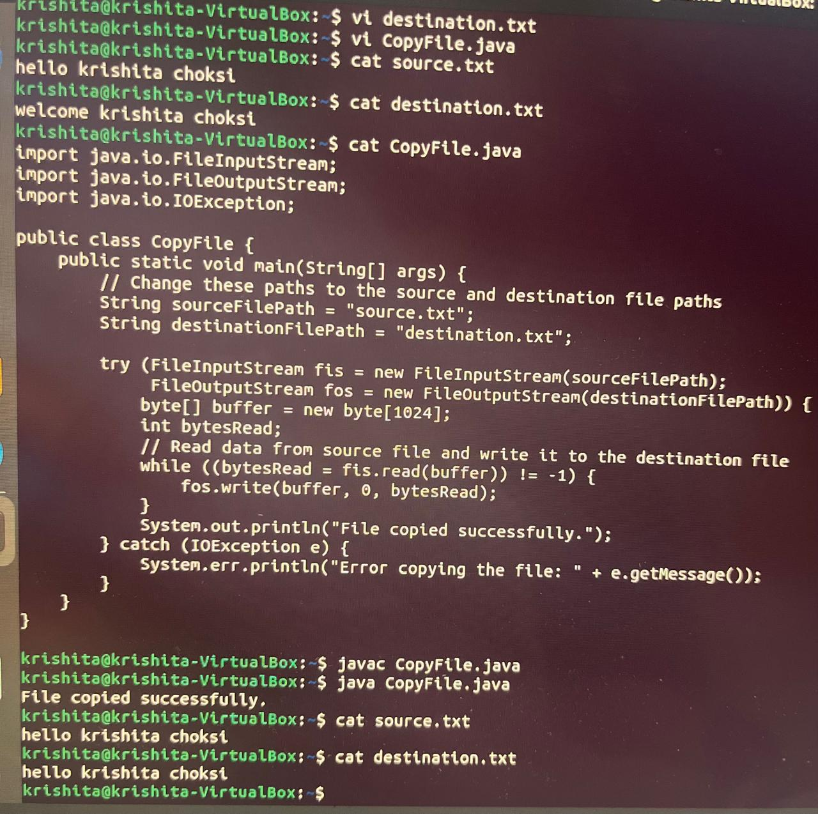

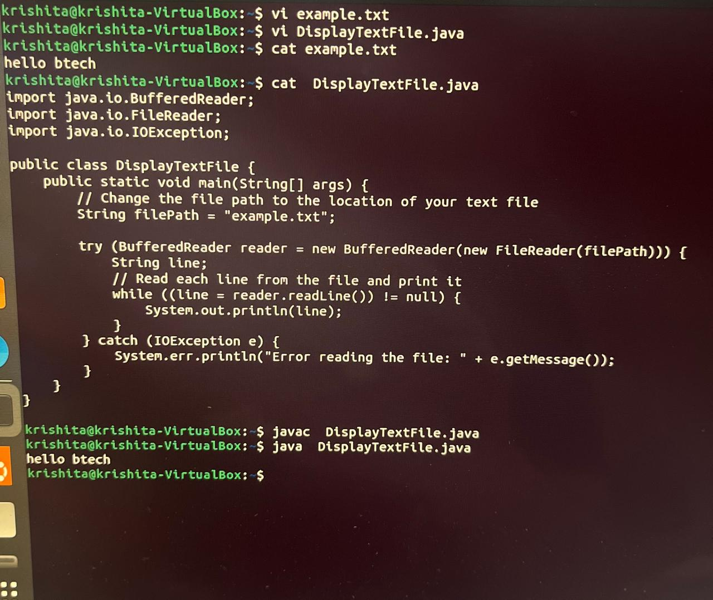

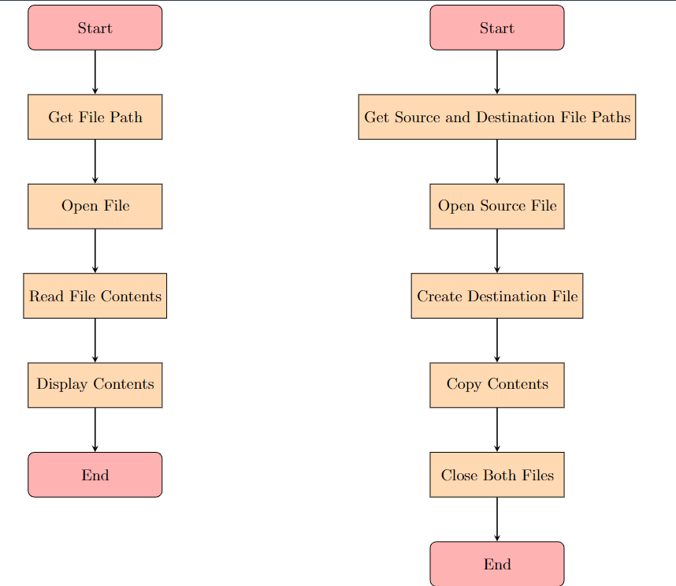

/////////////////////////////////////////////////////////////////////////////////////////////////////////

LAB6:

Develop the java ServerSocket and Socket based TCP/IP client server program and from client side send data records and and on server side store the data records.

### Problem Statement

The goal is to create a TCP/IP-based client-server application using Java, where:

1. **Client-Side**:
   * Sends data records to the server using a Socket connection.
2. **Server-Side**:
   * Receives data records from multiple clients using ServerSocket.
   * Stores the received data records (e.g., in a database, file, etc.).

### Output

#### Problem Statement Breakdown:

1. **Client-Side**:
   * **Data Sending**:
     + Develop a Java client (TCPClient) that connects to the server using a Socket.
     + Prepare and send data records (e.g., in the form of strings, objects serialized to bytes) to the server.
2. **Server-Side**:
   * **Data Reception**:
     + Implement a Java server (TCPServer) that listens for incoming client connections using ServerSocket.
     + Accept incoming client connections and handle each connection in a separate thread (ClientHandler).
     + Receive and process data records sent by clients.
   * **Data Storage**:
     + Store received data records in a persistent storage system (e.g., MySQL database, file system, etc.).

### Expected Output

#### Client-Side:

* **TCPClient**:
  + **Socket Connection**:
    - Create a Socket object and connect to the server's IP address (localhost or specific IP) and port (12345 for example).
  + **Data Sending**:
    - Prepare data records (e.g., strings, serialized objects) to be sent to the server.
    - Convert data into bytes (byte[]) if necessary and send them using OutputStream of the Socket.

#### Server-Side:

* **TCPServer**:
  + **ServerSocket Setup**:
    - Create a ServerSocket bound to a specified port (12345 for example).
    - Use accept() method of ServerSocket to accept incoming client connections in a loop.
  + **Data Reception**:
    - For each accepted client connection, create a new thread (ClientHandler) to handle data reception.
    - Read data from the client using InputStream of the Socket associated with the client connection.
  + **Data Storage**:
    - Process received data records (e.g., print on console, store in database).
    - Implement logic to persist data records in a database or file system.

### Example Output Flow:

1. **Client-Side**:
   * TCPClient establishes a connection to TCPServer using a Socket.
   * Sends data records (e.g., "Record 1", "Record 2") serialized to bytes to the server.
2. **Server-Side**:
   * TCPServer listens for incoming client connections using ServerSocket on port 12345.
   * Accepts connections from multiple clients and spawns a ClientHandler thread for each.
   * Each ClientHandler thread receives data records ("Record 1", "Record 2") from its respective client.
   * Processes and stores the received data records (e.g., prints on console, stores in a database).

### Conclusion

This setup demonstrates the implementation of a TCP/IP-based client-server application in Java using ServerSocket and Socket classes. It showcases how data records can be sent from clients to a server, where the server receives and stores these records. This approach ensures robust communication and data handling capabilities between client and server applications.

Code:

CLIENT:

package krishita.labsixclient;

/**

*

* @author Hp

*/

import java.io.*;

import java.net.*;

public class Labsixclient {

private static final String SERVER_ADDRESS = "localhost";

private static final int PORT = 1234;

public static void main(String[] args) {

try (Socket socket = new Socket(SERVER_ADDRESS, PORT);

PrintWriter writer = new PrintWriter(socket.getOutputStream(), true)) {

// Send data records to the server

writer.println("krishita");

writer.println("sanjay");

writer.println("choksi");

System.out.println("Data records sent to server.");

} catch (IOException e) {

e.printStackTrace();

}

}

}

//////////////////////////////////////////////////////////////////////////////////////////////////////

SERVER:

package krishita.labsixserver;

/**

*

* @author Hp

*/

import java.io.*;

import java.net.*;

public class Labsixserver {

private static final int PORT = 1234;

public static void main(String[] args) {

try (ServerSocket serverSocket = new ServerSocket(PORT)) {

System.out.println("Server started. Waiting for clients...");

while (true) {

Socket clientSocket = serverSocket.accept();

System.out.println("Client connected: " + clientSocket);

// Start a new thread to handle client's requests

new ClientHandler(clientSocket).start();

}

} catch (IOException e) {

e.printStackTrace();

}

}

static class ClientHandler extends Thread {

private Socket socket;

public ClientHandler(Socket socket) {

this.socket = socket;

}

public void run() {

try (BufferedReader reader = new BufferedReader(new InputStreamReader(socket.getInputStream()))) {

String data;

while ((data = reader.readLine()) != null) {

System.out.println("Received data from client: " + data);

// You can store the data records in a database or a file here

// For simplicity, we print the data to the console

}

} catch (IOException e) {

e.printStackTrace();

} finally {

try {

socket.close();

} catch (IOException e) {

e.printStackTrace();

}

}

}

}

}

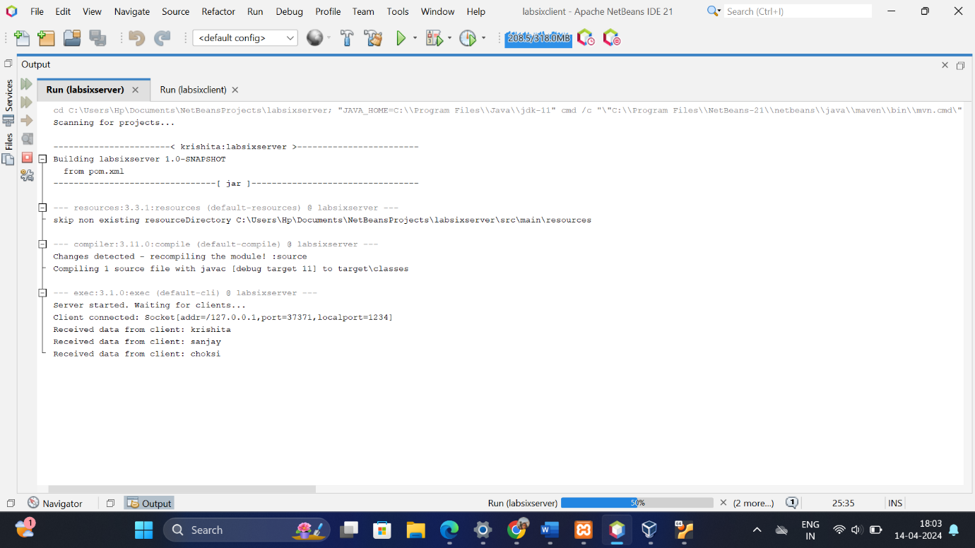

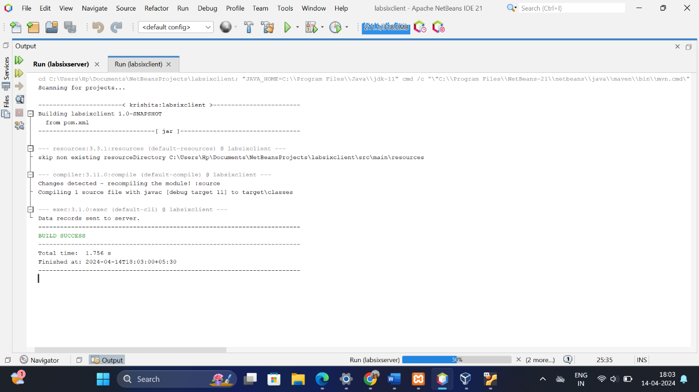

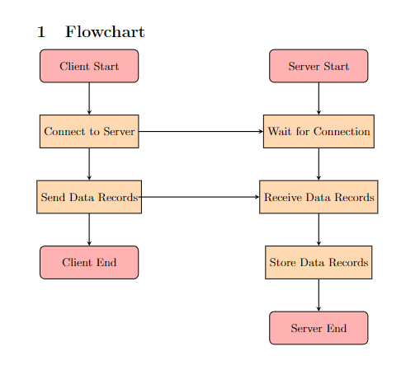

/////////////////////////////////////////////////////////////////////////////////////////////////////////

LAB7:

Develop the Datagram socket based UDP connection less program and send the String from client side and reverse it on server side and displayed reverse String on client side.

Certainly! Let's break down the problem statement and the expected output for developing a Datagram socket-based UDP connectionless program in Java. This program will involve sending a string from the client to the server, where the server will reverse the string and send it back to the client for display.

### Problem Statement

The objective is to create a UDP-based client-server application using Datagram sockets in Java. This application should:

1. **Client-Side**:
   * Send a string message to the server using a Datagram socket.
   * Display the original string sent to the server.
2. **Server-Side**:
   * Receive the string message from the client using a Datagram socket.
   * Reverse the received string.
   * Send the reversed string back to the client using the same Datagram socket.

### Output

#### Problem Statement Breakdown:

1. **Client-Side**:
   * **Send Operation**:
     + Implement a Java client (UDPClient) that creates a Datagram socket.
     + Convert a predefined string into bytes (byte[]) and send it to the server's IP address and port using DatagramPacket.
2. **Server-Side**:
   * **Receive Operation**:
     + Develop a Java server (UDPServer) that listens on a specified UDP port.
     + Receive the incoming Datagram packet containing the string from the client.
   * **Process and Respond**:
     + Reverse the received string.
     + Send the reversed string back to the client's IP address and port using another DatagramPacket.

### Expected Output

#### Client-Side:

* **UDPClient**:
  + **Send Operation**:
    - Create a Datagram socket (DatagramSocket) bound to any available port.
    - Convert the string ("Hello" for example) into bytes (byte[]) using getBytes() method.
    - Create a DatagramPacket containing the byte data and specify the server's IP address (localhost) and port (12345 for example).
    - Send the packet using send() method of DatagramSocket.
  + **Display**:
    - Print the original string sent to the server ("Hello").

#### Server-Side:

* **UDPServer**:
  + **Receive Operation**:
    - Create a Datagram socket (DatagramSocket) bound to a specified port (12345 for example).
    - Create a DatagramPacket to receive incoming data.
    - Use receive() method of DatagramSocket to wait for and receive the packet.
  + **Process and Respond**:
    - Convert the received byte data back into a string.
    - Reverse the string using StringBuilder.reverse() method.
    - Convert the reversed string back into bytes and create a response DatagramPacket.
    - Send the response packet using send() method of DatagramSocket to the client's IP address and port.
  + **Display**:
    - Print the reversed string on the server console.

### Example Output Flow:

1. **Client-Side**:
   * UDPClient sends the string "Hello" to UDPServer via Datagram socket.
   * Prints "Hello" as the original message sent.
2. **Server-Side**:
   * UDPServer receives the Datagram packet containing "Hello".
   * Reverses the string to "olleH".
   * Sends "olleH" back to UDPClient.
   * Prints "olleH" as the reversed message on the server console.

### Conclusion

This setup demonstrates the implementation of a UDP-based client-server application in Java, showcasing the use of Datagram sockets for connectionless communication. It effectively handles the sending of a string from the client to the server, the reversal of the string on the server side, and the display of the reversed string back to the client.

Code:

SERVER:

Package krishita.lab7server;

import java.net.*;

public class Lab7server {

public static void main(String[] args) {

try {

DatagramSocket serverSocket = new DatagramSocket(12346);

byte[] receiveData = new byte[1024];

byte[] sendData = new byte[1024];

while (true) {

DatagramPacket receivePacket = new DatagramPacket(receiveData, receiveData.length);

serverSocket.receive(receivePacket);

String sentence = new String(receivePacket.getData(), 0, receivePacket.getLength());

// Reverse the sentence

String reversedSentence = new StringBuilder(sentence).reverse().toString();

// Display the reversed sentence on the server side

System.out.println("Reversed sentence on server: " + reversedSentence);

InetAddress IPAddress = receivePacket.getAddress();

int port = receivePacket.getPort();

sendData = reversedSentence.getBytes();

DatagramPacket sendPacket = new DatagramPacket(sendData, sendData.length, IPAddress, port);

serverSocket.send(sendPacket);

}

} catch (Exception e) {

e.printStackTrace();

}

}

}

//////////////////////////////////////////////////////////////////////////////////////////////////////////

CLIENT:

Package krishita.lab7client;

import java.net.*;

import java.util.Scanner;

public class Lab7client {

public static void main(String[] args) {

try {

DatagramSocket clientSocket = new DatagramSocket();

InetAddress IPAddress = InetAddress.getByName("localhost");

byte[] sendData;

byte[] receiveData = new byte[1024];

Scanner scanner = new Scanner(System.in);

System.out.print("Enter a string: ");

String sentence = scanner.nextLine();

sendData = sentence.getBytes();

DatagramPacket sendPacket = new DatagramPacket(sendData, sendData.length, IPAddress, 12346);

clientSocket.send(sendPacket);

DatagramPacket receivePacket = new DatagramPacket(receiveData, receiveData.length);

clientSocket.receive(receivePacket);

String reversedSentence = new String(receivePacket.getData(), 0, receivePacket.getLength());

System.out.println("Reversed sentence: " + reversedSentence);

clientSocket.close();

} catch (Exception e) {

e.printStackTrace();

}

}

}

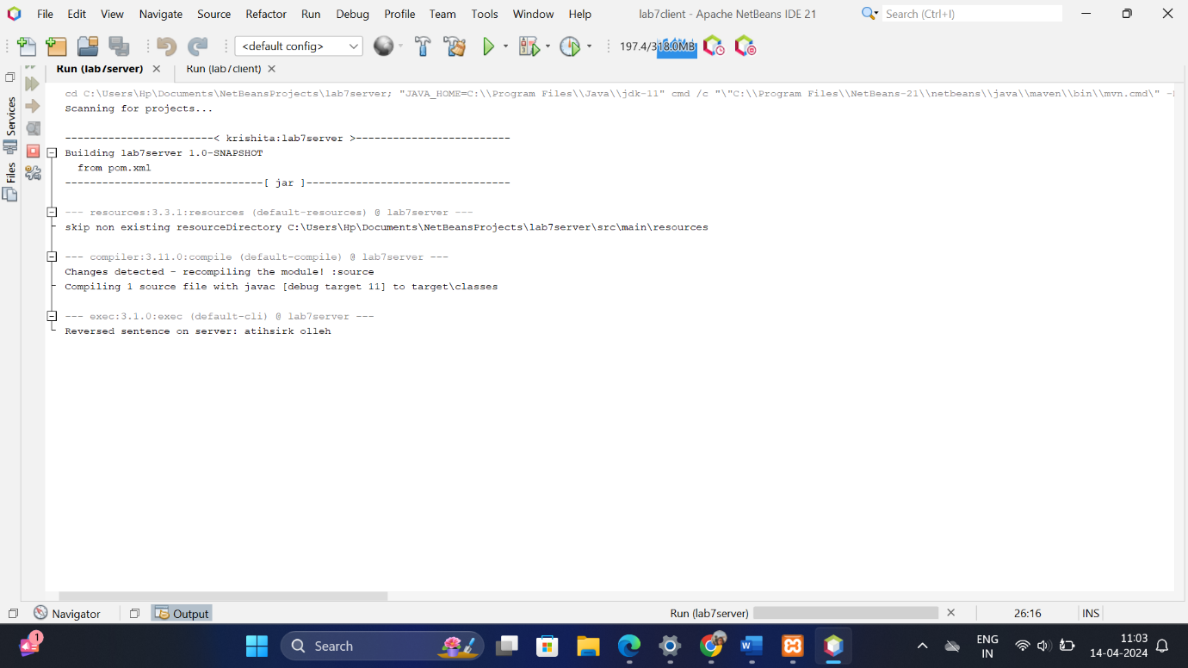

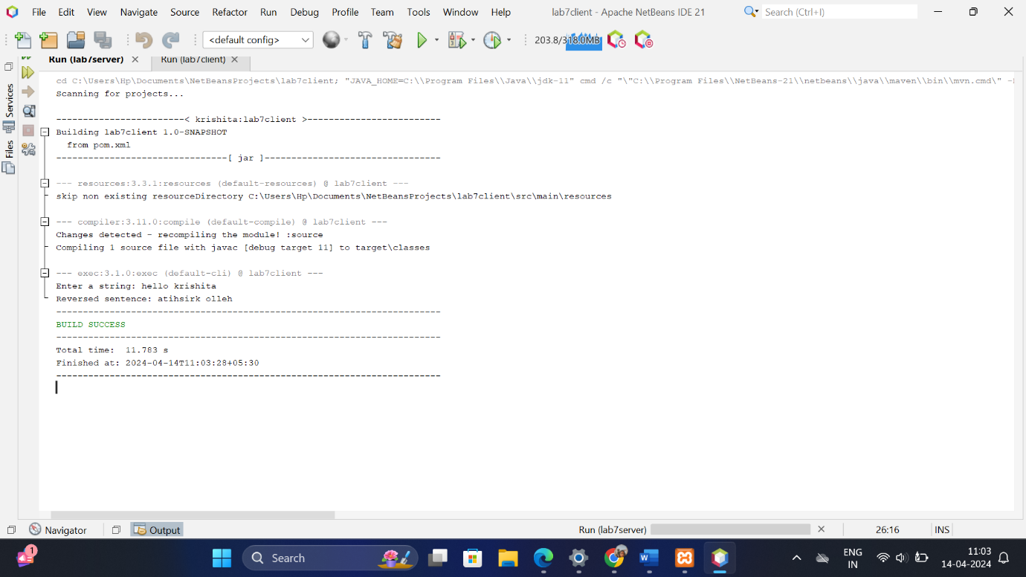

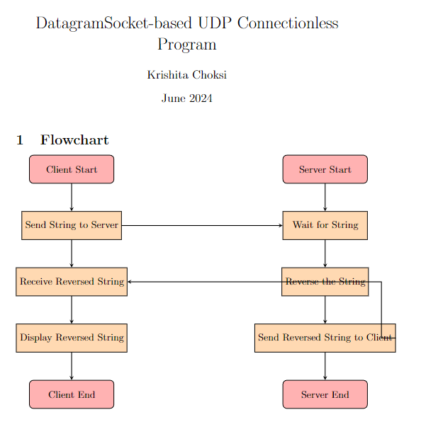

////////////////////////////////////////////////////////////////////////////////////////////////////////

LAB8:

Develop Multi-threaded client server Chat programming using TCP/IP Sockets and provide the chat-room facility for sharing the content among 3 or more chat clients

### Problem Statement

The goal is to create a multi-threaded client-server chat application using TCP/IP sockets. This application should facilitate real-time communication between multiple clients (at least 3) in a chat room. Key tasks include:

1. **Server Development**:
   * Implement a server that listens for incoming client connections.
   * Handle multiple client connections simultaneously using threads.
   * Manage the distribution of messages among connected clients in the chat room.
2. **Client Development**:
   * Develop a client application that connects to the server via TCP/IP.
   * Allow clients to send messages to the server and receive messages from other clients connected to the same chat room.
   * Provide a user interface for typing messages and viewing the chat history.

### Output

#### Problem Statement Breakdown:

1. **Server Development**:
   * **Server Setup**:
     + Create a server application (ChatServer) that listens on a specified port (e.g., 5555) for incoming client connections.
     + Use multithreading (Thread or ExecutorService) to handle multiple client connections concurrently.
     + Maintain a list of connected clients (ClientHandler threads) and manage communication between them.
2. **Client Development**:
   * **Client Setup**:
     + Implement a client application (ChatClient) that connects to the server using TCP/IP sockets.
     + Allow clients to send messages to the server using an input stream (OutputStream) and receive messages from other clients using an output stream (InputStream).
     + Display received messages in a chat window or console.
3. **Chat Room Functionality**:
   * **Message Distribution**:
     + Ensure that messages sent by any client are broadcasted to all other connected clients in the chat room.
     + Implement logic to handle message forwarding and ensure synchronization to prevent message conflicts.

### Expected Output

#### Server Development:

* **ChatServer**:
  + **Socket Initialization**:
    - Initialize a server socket (ServerSocket) on a specified port (e.g., 5555).
    - Listen for incoming client connections using serverSocket.accept() in a loop.
  + **Client Handling**:
    - For each client connection accepted, start a new ClientHandler thread.
    - Manage a list of ClientHandler threads to facilitate communication among multiple clients.
  + **Message Broadcasting**:
    - Implement methods for broadcasting messages received from one client to all other connected clients.

#### Client Development:

* **ChatClient**:
  + **Socket Connection**:
    - Create a socket (Socket) to connect to the server (localhost or specific IP address) on the designated port (5555).
  + **Input and Output Streams**:
    - Use InputStream to receive messages from the server.
    - Use OutputStream to send messages to the server.
  + **User Interface**:
    - Provide a graphical user interface (GUI) or command-line interface (CLI) for users to input messages and view the chat history.
    - Display incoming messages in real-time as they arrive from other clients.

#### Chat Room Functionality:

* **Message Distribution**:
  + Ensure that messages sent by any client are relayed to all other clients in the chat room.
  + Handle synchronization and thread safety to manage concurrent access to shared data structures (e.g., list of connected clients, message queue).

### Example Output Flow:

1. **Server Deployment**:
   * Start the ChatServer application on a server machine.
   * Server listens for incoming client connections on port 5555.
2. **Client Connections**:
   * Multiple instances of ChatClient connect to the ChatServer using TCP/IP sockets.
   * Each client establishes a unique connection to the server and joins the chat room.
3. **Real-time Communication**:
   * Clients can send messages to the server, which relays them to all other connected clients.
   * Messages appear in the chat windows of all clients in real-time, enabling seamless communication.

### Conclusion

This setup demonstrates the development of a multi-threaded client-server chat application using TCP/IP sockets in Java. It provides a robust framework for real-time communication among multiple clients in a chat room environment, showcasing efficient message handling and distribution across the network.

Code:

Server:

import java.io.IOException;

import java.io.PrintWriter;

import java.net.ServerSocket;

import java.net.Socket;

import java.util.ArrayList;

import java.util.List;

import java.util.Scanner;

public class Server {

private static final int PORT = 12345;

private static List<PrintWriter> clientWriters = new ArrayList<>();

public static void main(String[] args) {

try (ServerSocket serverSocket = new ServerSocket(PORT)) {

System.out.println("Server started...");

while (true) {

Socket clientSocket = serverSocket.accept();

System.out.println("New client connected: " + clientSocket);

PrintWriter writer = new PrintWriter(clientSocket.getOutputStream(), true);

clientWriters.add(writer);

Thread clientHandler = new Thread(new ClientHandler(clientSocket));

clientHandler.start();

}

} catch (IOException e) {

e.printStackTrace();

}

}

public static void broadcastMessage(String message) {

for (PrintWriter writer : clientWriters) {

writer.println(message);

}

}

private static class ClientHandler implements Runnable {

private Socket clientSocket;

private Scanner in;

public ClientHandler(Socket socket) {

this.clientSocket = socket;

}

@Override

public void run() {

try {

in = new Scanner(clientSocket.getInputStream());

while (in.hasNextLine()) {

String message = in.nextLine();

broadcastMessage(message);

}

} catch (IOException e) {

e.printStackTrace();

} finally {

try {

clientSocket.close();

} catch (IOException e) {

e.printStackTrace();

}

}

}

}

}

/////////////////////////////////////////////////////////////////////////////////////////////////////

Client:

import java.io.IOException;

import java.io.PrintWriter;

import java.net.Socket;

import java.util.Scanner;

public class Client {

private static final String SERVER_ADDRESS = "localhost";

private static final int SERVER_PORT = 12345;

public static void main(String[] args) {

try {

Socket socket = new Socket(SERVER_ADDRESS, SERVER_PORT);

System.out.println("Connected to server...");

PrintWriter out = new PrintWriter(socket.getOutputStream(), true);

Scanner scanner = new Scanner(System.in);

Thread receiveThread = new Thread(new ReceiveMessage(socket));

receiveThread.start();

while (true) {

String message = scanner.nextLine();

out.println(message);

}

} catch (IOException e) {

e.printStackTrace();

}

}

private static class ReceiveMessage implements Runnable {

private Socket socket;

private Scanner in;

public ReceiveMessage(Socket socket) {

this.socket = socket;

}

@Override

public void run() {

try {

in = new Scanner(socket.getInputStream());

while (in.hasNextLine()) {

String message = in.nextLine();

System.out.println(message);

}

} catch (IOException e) {

e.printStackTrace();

}

}

}

}

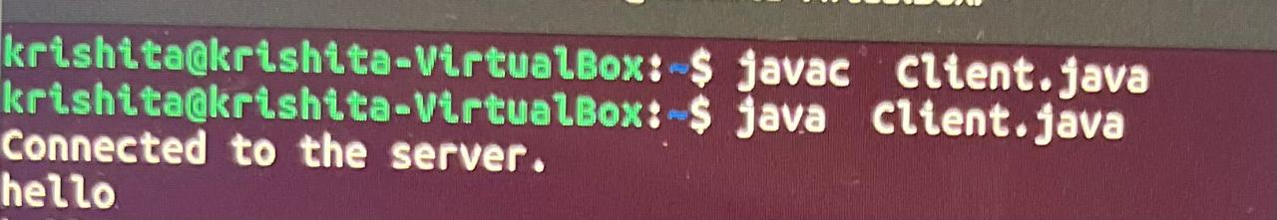

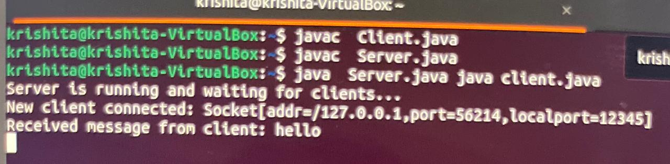

The outputs are only for 1 client,but multiple clients can be easily connected

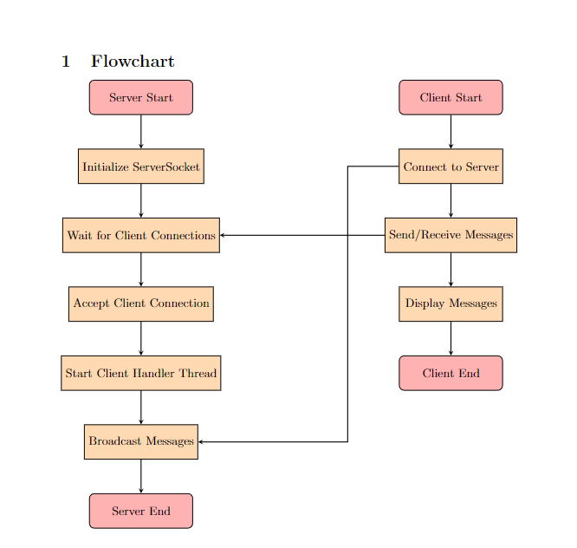

/////////////////////////////////////////////////////////////////////////////////////////////////////////

LAB9:

Develop the java Program using URL and URL connection class and show various URL attributes and develop URLConnection based string to display the any website header attributes and web site content.

### Problem Statement

The objective is to create a Java program that utilizes the URL and URLConnection classes to:

1. Fetch various attributes of a URL.
2. Retrieve and display both the header attributes and the content of a website.

### Output

#### Problem Statement Breakdown:

1. **URL Attributes**:
   * Implement Java code to create a URL object.
   * Use methods such as getProtocol(), getHost(), getPort(), getPath(), etc., to fetch and display various attributes of the URL.
2. **URLConnection and Website Data**:
   * Establish a URLConnection to connect to the URL.
   * Retrieve header attributes such as Content-Type, Content-Length, Date, etc., using methods like getContentType(), getContentLength(), getHeaderField(), etc.
   * Retrieve and display the content (HTML, text, etc.) of the website.

### Expected Output

#### URL Attributes:

* **URL Creation and Attributes**:
  + Create a URL object for a specified website URL.
  + Use methods to fetch and display attributes like:
    - Protocol (http, https)
    - Hostname (www.example.com)
    - Port number (80 for HTTP, 443 for HTTPS)
    - Path (/index.html, /about, etc.)

#### URLConnection and Website Data:

* **URLConnection Setup**:
  + Establish a URLConnection object using the openConnection() method of URL.
  + Cast to HttpURLConnection for HTTP specific methods if necessary (HttpURLConnection conn = (HttpURLConnection) url.openConnection()).
* **Header Attributes**:
  + Retrieve and display header attributes using methods like:
    - getContentType() to fetch the MIME type of the content.
    - getContentLength() to get the length of the content.
    - getHeaderField(key) to access specific header fields (e.g., Date, Server).
* **Website Content**:
  + Read and display the content of the website using input streams (InputStream).
  + Convert byte streams to character streams using BufferedReader for easier reading and displaying.

### Example Output Flow:

1. **URL Attributes**:
   * Create a URL object for https://www.example.com.
   * Use methods (getProtocol(), getHost(), getPort(), getPath()) to fetch and display attributes:
     + Protocol: https
     + Host: www.example.com
     + Port: 443
     + Path: / (root)
2. **URLConnection and Website Data**:
   * Establish a URLConnection to https://www.example.com.
   * Retrieve and display header attributes:
     + Content-Type: text/html; charset=UTF-8
     + Content-Length: 12345 bytes (example value)
     + Date: Tue, 29 Jun 2024 12:00:00 GMT
     + Server: Apache/2.4.38 (Unix)
   * Read and display the content of the website (HTML or text).

### Conclusion

This setup effectively demonstrates the use of Java's URL and URLConnection classes to fetch and display both the attributes and content of a website. It provides insight into how to programmatically access web resources, retrieve essential information such as header attributes, and handle website content in Java applications.

Code:

Package krishita.lab9;

import java.io.BufferedReader;

import java.io.IOException;

import java.io.InputStreamReader;

import java.net.URL;

import java.net.URLConnection;

public class Lab9 {

public static void main(String[] args) {

String urlString = "https://www.example.com"; // Replace with the URL of the website you want to retrieve information from

try {

// Create a URL object

URL url = new URL(urlString);

// Display various URL attributes

System.out.println("Protocol: " + url.getProtocol());

System.out.println("Host: " + url.getHost());

System.out.println("Port: " + url.getPort());

System.out.println("Path: " + url.getPath());

System.out.println("Query: " + url.getQuery());

// Open a connection to the URL

URLConnection connection = url.openConnection();

// Retrieve and display header attributes

System.out.println("\nHeader Attributes:");

connection.getHeaderFields().forEach((key, value) -> System.out.println(key + ": " + value));

// Retrieve and display website content

System.out.println("\nWebsite Content:");

BufferedReader reader = new BufferedReader(new InputStreamReader(connection.getInputStream()));

String line;

while ((line = reader.readLine()) != null) {

System.out.println(line);

}

reader.close();

} catch (IOException e) {

e.printStackTrace();

}

}

}

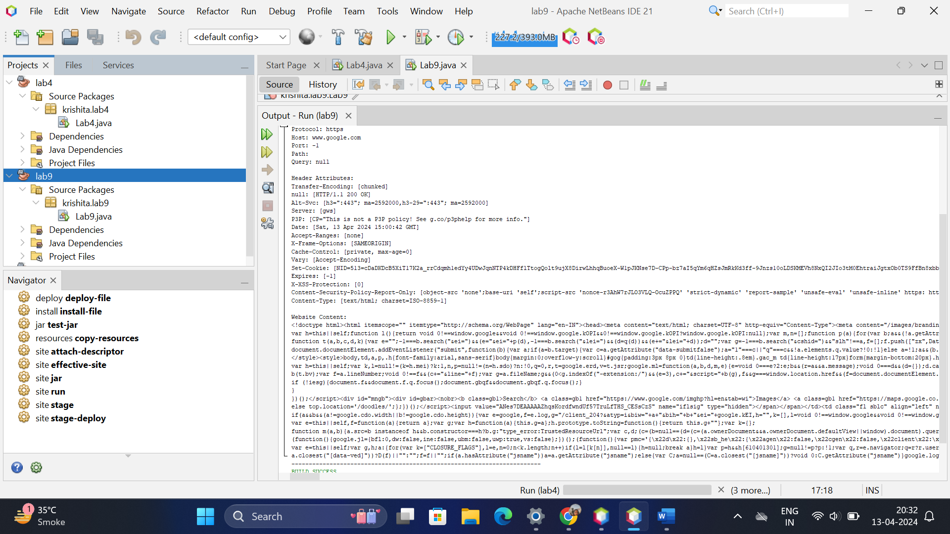

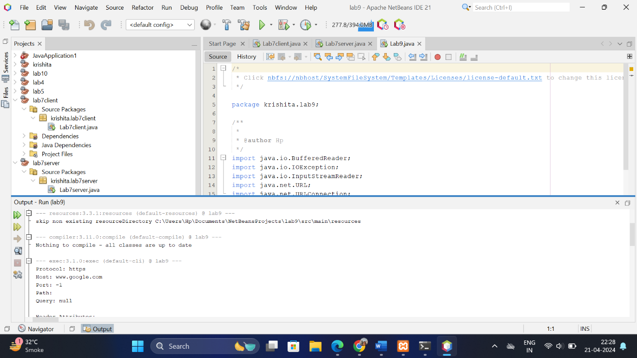

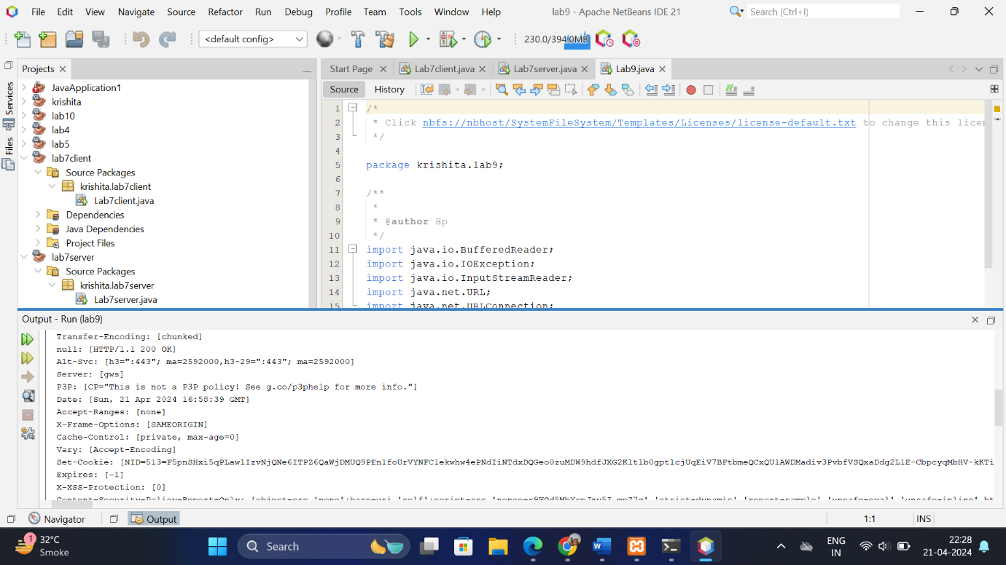

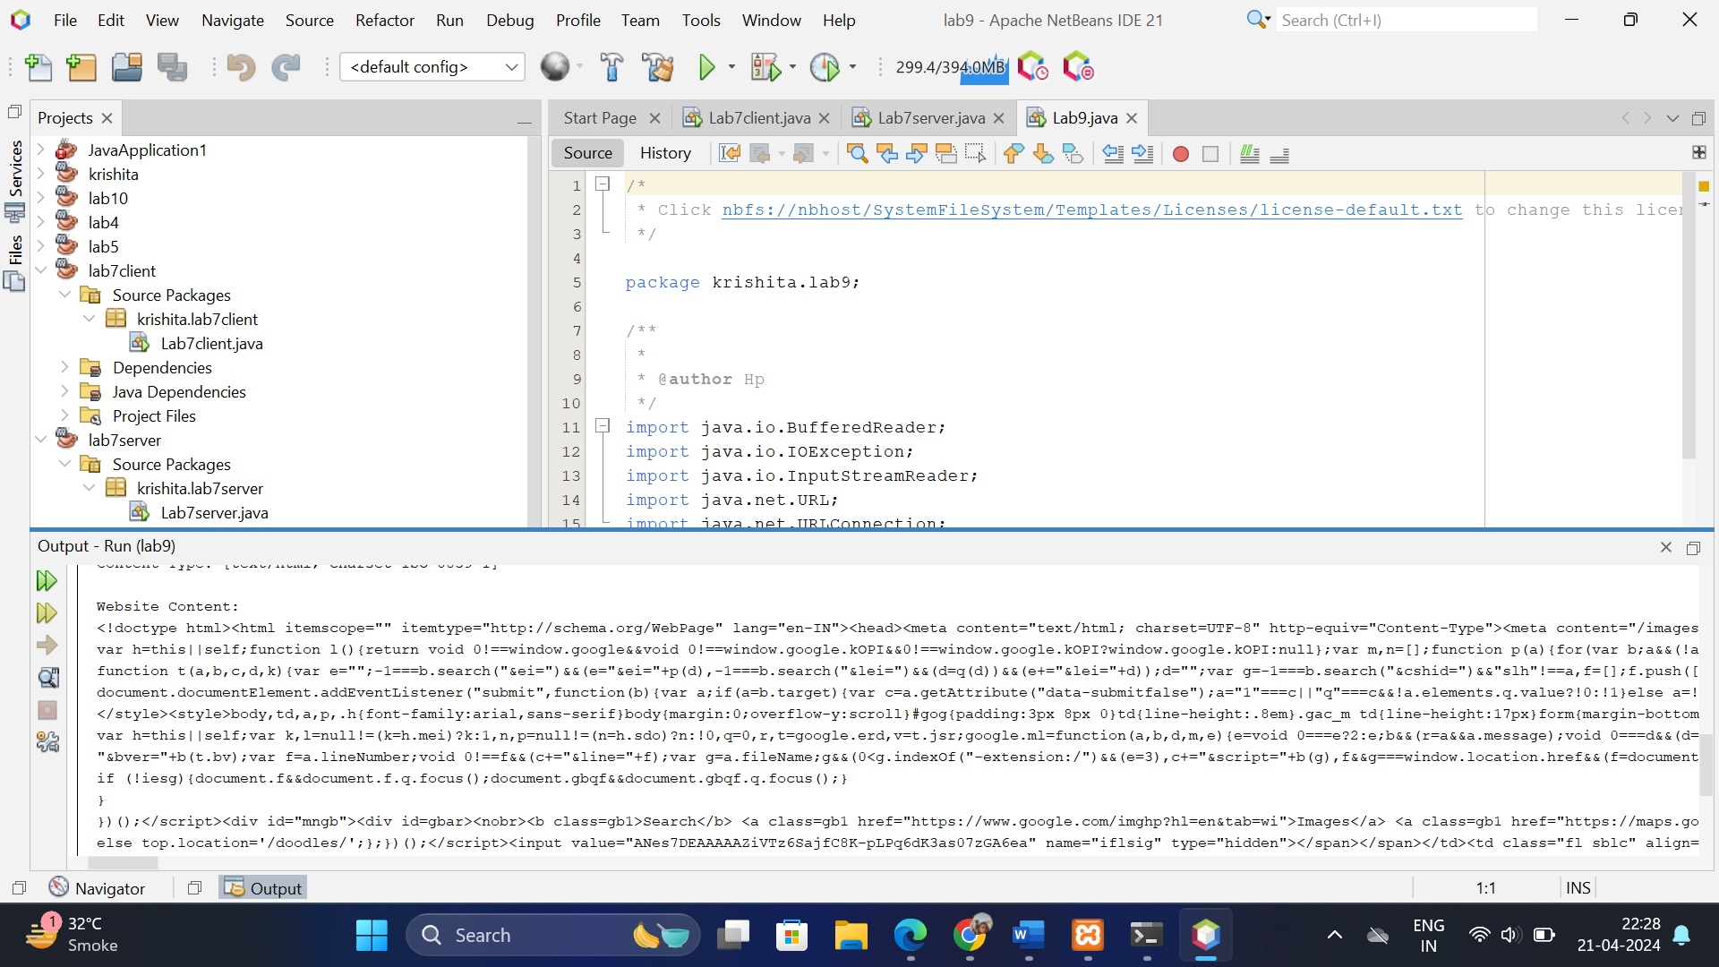

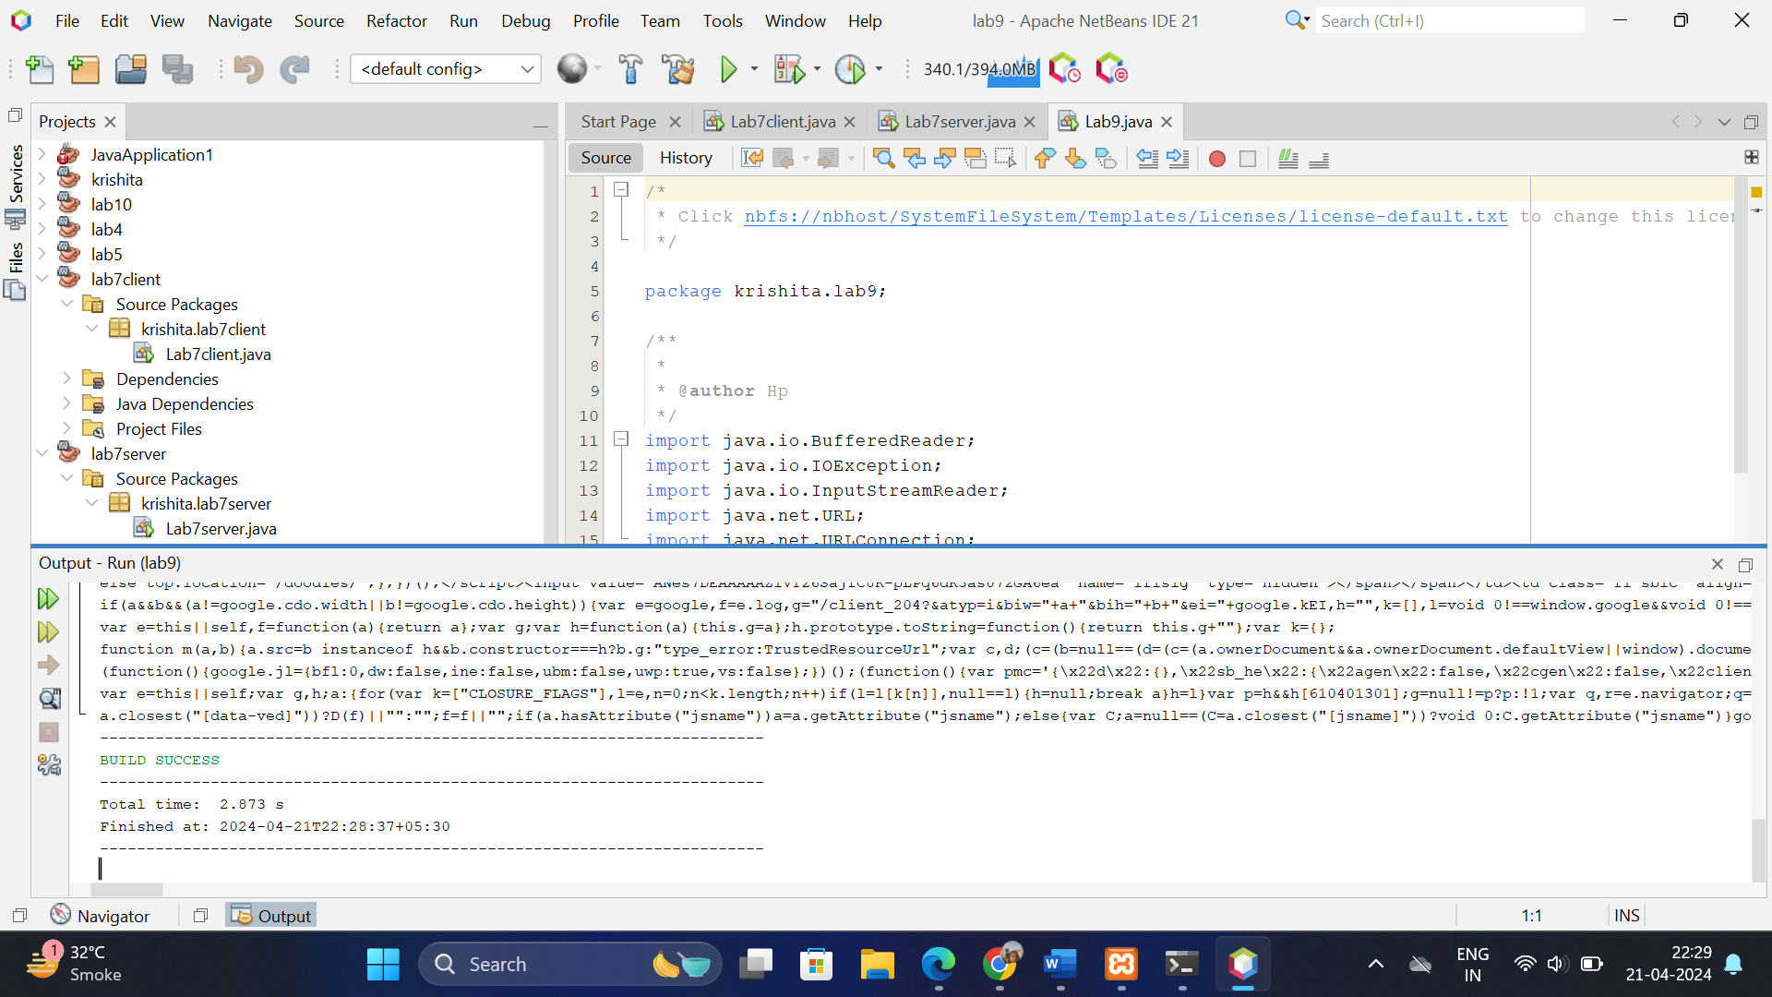

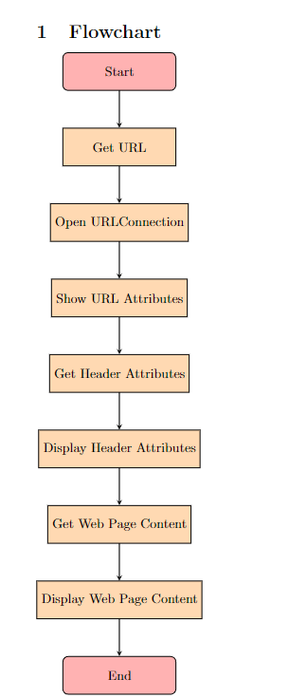

////////////////////////////////////////////////////////////////////////////////////////////////////////

LAB10:

Develop JDBC based login authentication system where store the users and password data in MySQL database. Show both the successful and failure login use case.

### Problem Statement

The objective is to create a login authentication system using Java Database Connectivity (JDBC) and MySQL. This system involves the following tasks:

1. **Database Setup**:
   * Design and create a MySQL database (userdb) with a table (users) to store user credentials.
   * Define columns such as username and password to store user information securely.
2. **User Interface**:
   * Develop a simple login form (login.html) where users can enter their username and password.
3. **Authentication Logic**:
   * Implement a Java servlet (LoginServlet) that handles user login requests.
   * Validate the entered username and password against the records stored in the users table in MySQL.
4. **Login Use Cases**:
   * **Successful Login**: Redirect the user to a welcome page (welcome.jsp) upon successful authentication.
   * **Failure Login**: Display an error message on the login form if the credentials are incorrect.

### Output

#### Problem Statement Breakdown:

1. **Database Setup**:
   * **Table Creation**:
     + Create a MySQL table named users with columns username (VARCHAR) and password (VARCHAR).
     + Use appropriate SQL queries (CREATE TABLE) to define table structure.
2. **User Interface**:
   * **Login Form (login.html)**:
     + Design an HTML form with input fields for username and password.
     + Use <form> tag with method="post" to submit data securely.
3. **Authentication Logic**:
   * **Servlet (LoginServlet.java)**:
     + Implement a Java servlet (LoginServlet) that extends HttpServlet.
     + Override the doPost() method to handle HTTP POST requests sent by the login form.
     + Retrieve form parameters (username, password) using request.getParameter().
     + Use JDBC (Connection, PreparedStatement) to connect to the MySQL database.
     + Query the users table to verify the entered credentials (SELECT query).
     + Redirect to welcome.jsp on successful login or reload login.html with an error message on failure.
4. **Login Use Cases**:
   * **Successful Login**:
     + Redirect the user to welcome.jsp upon matching username and password in the database.
     + Display a personalized welcome message or user information.
   * **Failure Login**:
     + Reload the login.html page with an error message (e.g., "Invalid username or password").
     + Prompt the user to retry entering their credentials.

#### Expected Output:

* **Database Setup**:
  + **Table Creation**:
    - Create users table with columns username (VARCHAR) and password (VARCHAR) using appropriate SQL commands.
* **User Interface**:
  + **Login Form (login.html)**:
    - Provides input fields for username and password.
    - Submits data securely to LoginServlet via HTTP POST method.
* **Authentication Logic**:
  + **Servlet (LoginServlet.java)**:
    - Receives POST requests from login.html.
    - Validates entered credentials against stored records in the users table using JDBC.
    - Redirects to welcome.jsp on successful login.
    - Reloads login.html with error message on login failure.

#### Example Output Flow:

1. **Database Setup**:
   * users table created with columns username and password.
2. **User Interface**:
   * User accesses login.html in a web browser.
   * Enters username and password and submits the form.
3. **Authentication Logic**:
   * LoginServlet receives POST request from login.html.
   * Retrieves entered username and password.
   * Validates credentials against records in the users table using JDBC.
   * If credentials match:
     + Redirects user to welcome.jsp.
     + Displays personalized welcome message.
   * If credentials do not match:
     + Reloads login.html with an error message.

### Conclusion

This setup effectively demonstrates the development of a JDBC-based login authentication system using Java servlets and MySQL. It ensures secure user authentication and provides a seamless user experience with appropriate feedback for both successful and failed login attempts.

Code:

import java.sql.*;

import java.util.Scanner;

public class LoginApplication{

private static boolean rememberMe = false;

private static String loggedInUsername = "";

public static boolean login(String uname, String pass) throws Exception {

Class.forName("com.mysql.cj.jdbc.Driver");

Connection con = DriverManager.getConnection(

"jdbc:mysql://localhost:3306/nfsu_dbms?useSSL=false","root","0000");

Statement stmt=con.createStatement();

ResultSet rs=stmt.executeQuery("select * from login");

while(rs.next()) {

if (rs.getString(1).equals(uname) & rs.getString(2).endsWith(pass)) {

return true;

}

}

stmt.close();

con.close();

return false;

}

public static void main(String[] args) throws Exception {

Scanner scanner = new Scanner(System.in);

System.out.println("Welcome to Login Application!");

while (true) {

System.out.println("\nOptions:");

System.out.println("1. Login");

System.out.println("2. Logout");

System.out.println("3. Exit");

System.out.print("Choose an option: ");

int choice = scanner.nextInt();

scanner.nextLine(); // Consume newline

switch (choice) {

case 1:

login(scanner);

break;

case 2:

logout();

break;

case 3:

System.out.println("Exiting...");

scanner.close();

System.exit(0);

default:

System.out.println("Invalid option. Please try again.");

}

}

}

// Method to handle login

private static void login(Scanner scanner) throws Exception {

if (!loggedInUsername.isEmpty()) {

System.out.println("You are already logged in as " + loggedInUsername);

return;

}

System.out.print("Enter your username: ");

String enteredUsername = scanner.nextLine();

System.out.print("Enter your password: ");

String enteredPassword = scanner.nextLine();

// Validate credentials

if (login(enteredUsername, enteredPassword)) {

loggedInUsername = enteredUsername;

System.out.println("Login successful!");

// Remember login if requested

System.out.print("Do you want to remember your login? (yes/no): ");

String rememberChoice = scanner.nextLine();

if (rememberChoice.equalsIgnoreCase("yes")) {

rememberMe = true;

} else {

rememberMe = false;

}

} else {

System.out.println("Login failed. Incorrect username or password.");

}

}

// Method to handle logout

private static void logout() {

if (!loggedInUsername.isEmpty()) {

System.out.println("Logging out user: " + loggedInUsername);

if (!rememberMe) {

loggedInUsername = "";

}

} else {

System.out.println("You are not currently logged in.");

}

}

}

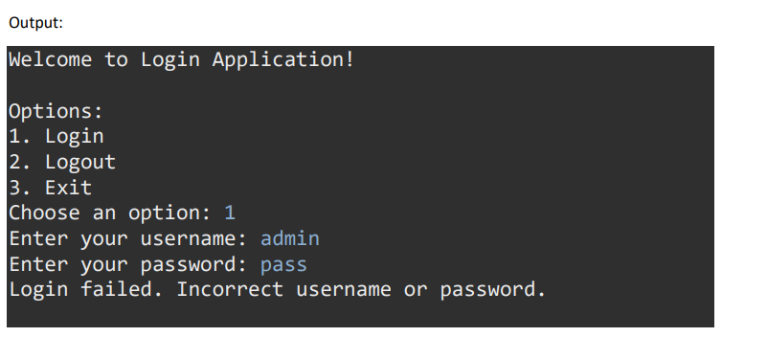

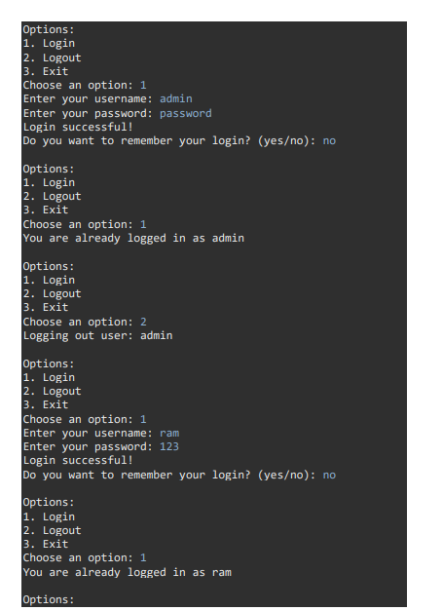

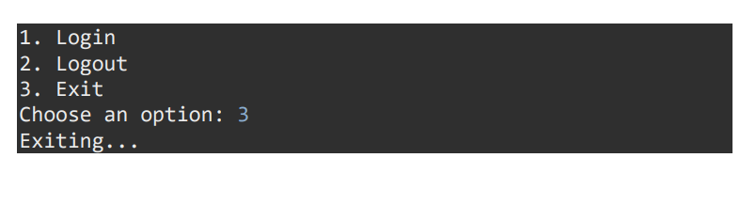

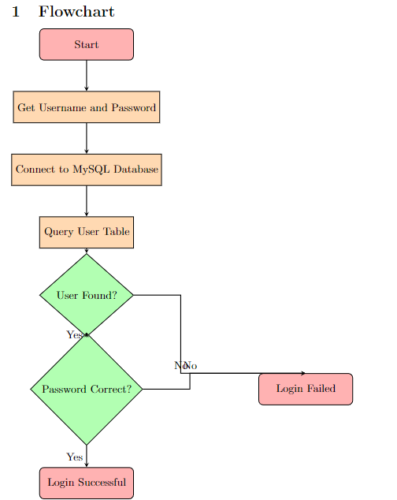

LAB11:

Develop the Student System for any college class room or university and develop the student and teacher tables in MySQL database and provide search based on classroom search or Teacher name search for showing the students in a classroom or students in classroom or both

**Problem Statement**

The objective is to create a student management system for a college or university that involves the following tasks:

1. **Database Setup**:
   * Design and create MySQL tables for storing student and teacher information.
   * Establish relationships between tables (if necessary) to represent classroom associations.
2. **Data Management**:
   * Populate the student and teacher tables with sample data.
   * Ensure data integrity and consistency by defining appropriate constraints (e.g., primary keys, foreign keys).
3. **Search Functionality**:
   * Implement search functionalities based on:
     + **Classroom**: Retrieve students enrolled in a specific classroom.
     + **Teacher Name**: Retrieve students taught by a specific teacher.
     + **Combined Search**: Retrieve students based on both classroom and teacher name.

**Output**

**Problem Statement Breakdown:**

1. **Database Setup**:
   * **Tables**:
     + **Student Table**: Stores information such as student ID, name, email, classroom, etc.
     + **Teacher Table**: Stores information such as teacher ID, name, email, etc.
     + **Classroom Table** (if necessary): Represents classroom details, linked to students and teachers.
2. **Data Management**:
   * **Populate Tables**:
     + Insert sample records into the student and teacher tables.
     + Ensure each student is associated with a classroom and each teacher is assigned to specific classrooms.
3. **Search Functionality**:
   * **Classroom Search**:
     + Allow users to search for students by entering a classroom name or ID.
     + Display a list of students enrolled in the specified classroom.
   * **Teacher Name Search**:
     + Provide a search option where users can enter a teacher's name to retrieve students taught by that teacher.
     + Display a list of students associated with the specified teacher.
   * **Combined Search**:
     + Implement a feature where users can search by both classroom and teacher name simultaneously.
     + Display a list of students who match both criteria.

**Expected Output:**

* **Database Setup**:
  + **Tables Creation**:
    - Create student and teacher tables with appropriate columns (id, name, email, etc.).
    - Establish relationships using foreign keys (e.g., classroom_id in the student table referencing id in the classroom table).
* **Data Management**:
  + **Insert Data**:
    - Populate student and teacher tables with sample records using SQL INSERT statements.
    - Ensure data consistency and integrity by enforcing constraints (e.g., primary keys, foreign keys).
* **Search Functionality**:
  + **Classroom Search**:
    - User enters a classroom name or ID.
    - System retrieves and displays students enrolled in the specified classroom.
  + **Teacher Name Search**:
    - User enters a teacher's name.
    - System retrieves and displays students taught by the specified teacher.
  + **Combined Search**:
    - User enters both classroom name/ID and teacher's name.
    - System retrieves and displays students who are enrolled in the specified classroom and taught by the specified teacher.

**Example Output Flow:**

1. **Database Setup**:
   * Tables (student, teacher) are created with appropriate columns.
   * Relationships are defined to maintain data integrity.
2. **Data Management**:
   * Sample data (students and teachers) are inserted into the respective tables.
   * Each student is associated with a specific classroom, and each teacher is linked to one or more classrooms.
3. **Search Functionality**:
   * **Scenario 1: Classroom Search**:
     + User inputs a classroom name or ID (e.g., "Class A").
     + System retrieves all students enrolled in "Class A" and displays their information.
   * **Scenario 2: Teacher Name Search**:
     + User inputs a teacher's name (e.g., "Mr. Smith").
     + System retrieves all students taught by "Mr. Smith" and displays their information.
   * **Scenario 3: Combined Search**:
     + User inputs both a classroom name/ID (e.g., "Class A") and a teacher's name (e.g., "Mr. Smith").
     + System retrieves students who are enrolled in "Class A" and taught by "Mr. Smith," displaying their information.

**Conclusion**

This setup effectively demonstrates the development of a Student System for a college or university, including database design, data management, and search functionalities. It allows for efficient retrieval of student information based on classroom or teacher criteria, enhancing organizational and administrative capabilities within educational institutions.

CODE:

import java.sql.*;

import java.util.Scanner;

public class StudentSystem {

// JDBC URL, username, and password of MySQL server

private static final String JDBC_URL = "jdbc:mysql://localhost:3306/nfsu_dbms";

private static final String USERNAME = "root";

private static final String PASSWORD = "0000";

// Search students by classroom

public static void searchStudentsByClassroom(String roomNumber) throws Exception{

Class.forName("com.mysql.cj.jdbc.Driver");

try (Connection conn = DriverManager.getConnection(JDBC_URL, USERNAME, PASSWORD)) {

String sql = "SELECT StudentID, Students.FirstName, Students.LastName, Age, Gender FROM

Students INNER JOIN Classroom ON Students.ClassroomID = Classroom.ClassroomID WHERE

RoomNumber = ?";

PreparedStatement statement = conn.prepareStatement(sql);

statement.setString(1, roomNumber);

ResultSet resultSet = statement.executeQuery();

System.out.println("Students of class number "+roomNumber+" : ");

System.out.println("---------------------------------------------------------------------------------------------");

System.out.printf("%10s %15s %15s %10s %10s", "STUDENT_ID", "FIRST_NAME",

"LAST_NAME", "AGE", "GENDER");

System.out.println();

System.out.println("---------------------------------------------------------------------------------------------");

while (resultSet.next()) {

int studentID = resultSet.getInt("StudentID");

String firstName = resultSet.getString("FirstName");

String lastName = resultSet.getString("LastName");

int age = resultSet.getInt("Age");

String gender = resultSet.getString("Gender");

// System.out.println(studentID+" "+firstName + " " + lastName+" "+age+" "+gender);

System.out.format("%10s %15s %15s %10s %10s", studentID, firstName, lastName, age,

gender);

System.out.println();

}

System.out.println("----------------------------------------------------------------------------------------------");

} catch (SQLException e) {

e.printStackTrace();

}

}

// Search students by teacher name

public static void searchStudentsByTeacher(String teacherFirstName, String teacherLastName)

throws Exception {

Class.forName("com.mysql.cj.jdbc.Driver");

try (Connection conn = DriverManager.getConnection(JDBC_URL, USERNAME, PASSWORD)) {

String sql = "SELECT StudentID, Students.FirstName, Students.LastName, Age, Gender FROM

Students INNER JOIN Teachers ON Students.ClassroomID = Teachers.ClassroomID WHERE

Teachers.FirstName = ? or Teachers.LastName = ?";

PreparedStatement statement = conn.prepareStatement(sql);

statement.setString(1, teacherFirstName);

statement.setString(2, teacherLastName);

ResultSet resultSet = statement.executeQuery();

System.out.println("Students of class with Class Teacher "+teacherFirstName + " " +

teacherLastName+" : ");

System.out.println("---------------------------------------------------------------------------------------------");

System.out.printf("%10s %15s %15s %10s %10s", "STUDENT_ID", "FIRST_NAME",

"LAST_NAME", "AGE", "GENDER");

System.out.println();

System.out.println("---------------------------------------------------------------------------------------------");

while (resultSet.next()) {

int studentID = resultSet.getInt("StudentID");

String firstName = resultSet.getString("FirstName");

String lastName = resultSet.getString("LastName");

int age = resultSet.getInt("Age");

String gender = resultSet.getString("Gender");

// System.out.println(studentID+" "+firstName + " " + lastName+" "+age+" "+gender);

System.out.format("%10s %15s %15s %10s %10s", studentID, firstName, lastName, age,

gender);

System.out.println();

}

System.out.println("----------------------------------------------------------------------------------------------");

} catch (SQLException e) {

e.printStackTrace();

}

}

// Add new student

public static void addStudent(String firstName, String lastName, int age, String gender, int

classroomID) {

try (Connection conn = DriverManager.getConnection(JDBC_URL, USERNAME, PASSWORD)) {

String sql = "INSERT INTO Students (FirstName, LastName, Age, Gender, ClassroomID) VALUES

(?, ?, ?, ?, ?)";

PreparedStatement statement = conn.prepareStatement(sql);

statement.setString(1, firstName);

statement.setString(2, lastName);

statement.setInt(3, age);

statement.setString(4, gender);

statement.setInt(5, classroomID);

int rowsInserted = statement.executeUpdate();

if (rowsInserted > 0) {

System.out.println("Student added successfully.");

}

} catch (SQLException e) {

e.printStackTrace();

}

}

// Delete student

public static void deleteStudent(int studentID) {

try (Connection conn = DriverManager.getConnection(JDBC_URL, USERNAME, PASSWORD)) {

String sql = "DELETE FROM Students WHERE StudentID=?";

PreparedStatement statement = conn.prepareStatement(sql);

statement.setInt(1, studentID);

int rowsDeleted = statement.executeUpdate();

if (rowsDeleted > 0) {

System.out.println("Student deleted successfully.");

}

} catch (SQLException e) {

e.printStackTrace();

}

}

// View student details

public static void viewStudentDetails(int studentID) {

try (Connection conn = DriverManager.getConnection(JDBC_URL, USERNAME, PASSWORD)) {

String sql = "SELECT * FROM Students WHERE StudentID=?";

PreparedStatement statement = conn.prepareStatement(sql);

statement.setInt(1, studentID);

ResultSet resultSet = statement.executeQuery();

if (resultSet.next()) {

System.out.println("Student ID: " + resultSet.getInt("StudentID"));

System.out.println("First Name: " + resultSet.getString("FirstName"));

System.out.println("Last Name: " + resultSet.getString("LastName"));

System.out.println("Age: " + resultSet.getInt("Age"));

System.out.println("Gender: " + resultSet.getString("Gender"));

System.out.println("Classroom ID: " + resultSet.getInt("ClassroomID"));

} else {

System.out.println("Student not found.");

}

} catch (SQLException e) {

e.printStackTrace();

}

}

public static void main(String[] args) throws Exception{

// addStudent("Joey", "Ray", 20, "Male", 1);

// deleteStudent(1);

// viewStudentDetails(1);

// searchStudentsByClassroom("101");

// searchStudentsByTeacher("David","Wilson");

try (Scanner scanner = new Scanner(System.in)) {

while (true) {

System.out.println("\nStudent System Menu:");

System.out.println("1. Add Student");

System.out.println("2. Delete Student");

System.out.println("3. View Student Details");

System.out.println("4. Search Students by Classroom");

System.out.println("5. Search Students by Teacher Name");

System.out.println("6. Exit");

System.out.print("Enter your choice: ");

int choice = scanner.nextInt();

scanner.nextLine();

switch (choice) {

case 1:

// Add Student

System.out.println("\nAdding a new student:");

System.out.print("Enter first name: ");

String firstName = scanner.nextLine();

System.out.print("Enter last name: ");

String lastName = scanner.nextLine();

System.out.print("Enter age: ");

int age = scanner.nextInt();

scanner.nextLine(); // Consume newline character

System.out.print("Enter gender: ");

String gender = scanner.nextLine();

System.out.print("Enter classroom ID: ");

int classroomID = scanner.nextInt();

scanner.nextLine(); // Consume newline character

addStudent(firstName, lastName, age, gender, classroomID);

break;

case 2:

// Delete Student

System.out.println("\nDelete a student:");

System.out.print("Enter student Id to delete: ");

int studentID_del = scanner.nextInt();

scanner.nextLine(); // Consume newline character

deleteStudent(studentID_del);

break;

case 3:

// View Student Details

System.out.println("\nViewing Student Details:");

System.out.print("Enter student Id to view details : ");

int studentID_view = scanner.nextInt();

scanner.nextLine(); // Consume newline character

viewStudentDetails(studentID_view);

break;

case 4:

// Search Students by Classroom

System.out.println("\nSearch Students by Classroom:");

System.out.print("Enter Classroom Room Number: ");

String room = scanner.nextLine();

searchStudentsByClassroom(room);

break;

case 5:

// Search Students by Teacher Name

System.out.println("\nSearch Students by Teacher Name:");

System.out.print("Enter Class Teacher First Name : ");

String teacherfn = scanner.nextLine();

System.out.print("Enter Class Teacher Last Name : ");

String teacherln = scanner.nextLine();

searchStudentsByTeacher(teacherfn, teacherln);

break;

case 6:

// Exit

System.out.println("Exiting...");

System.exit(0);

break;

default:

System.out.println("Invalid choice. Please enter a number between 1

and 6.");

}

}

}

}

}

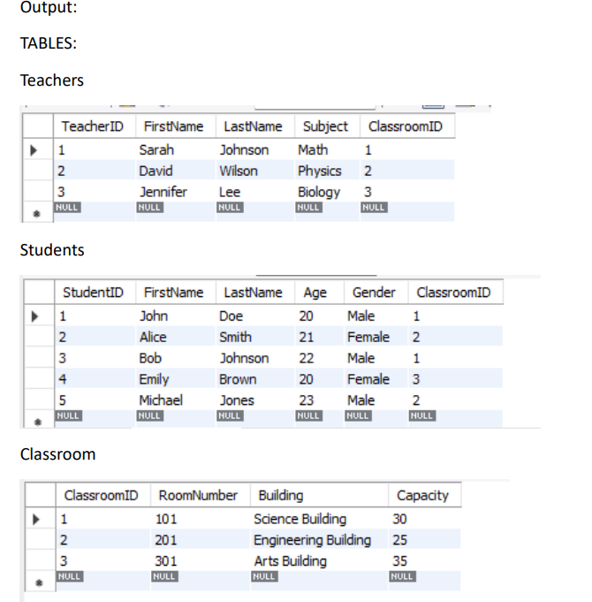

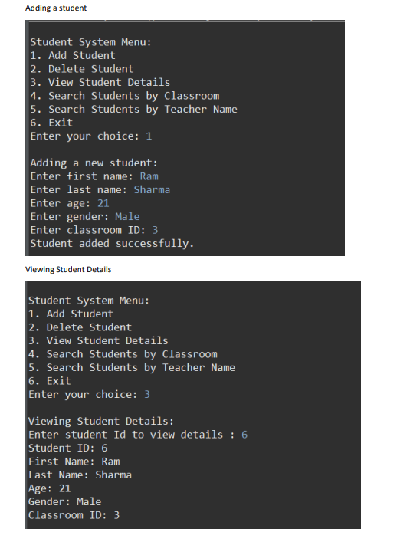

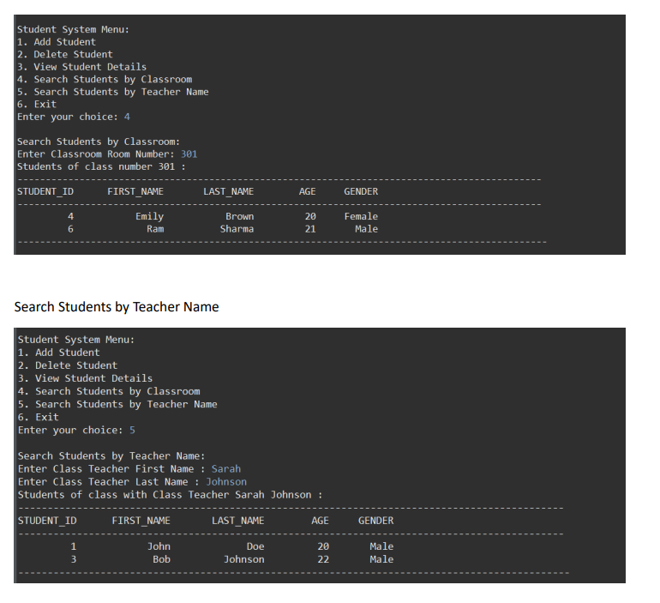

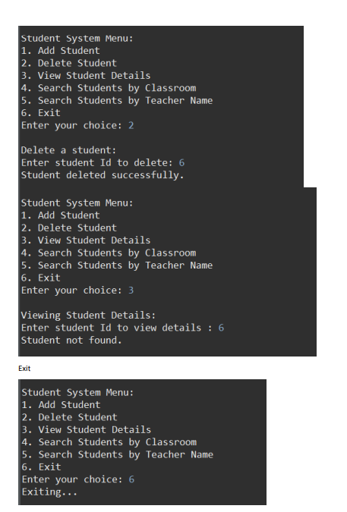

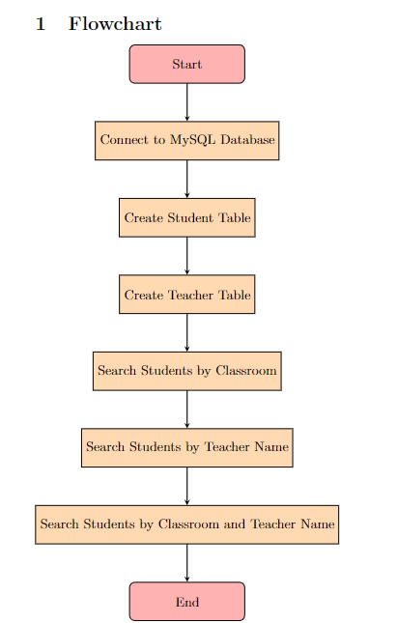

////////////////////////////////////////////////////////////////////////////////////////////////////

LAB12:

Develop Server side Servlet on tomcat Server and for collecting the data from HTML form and store it via Java Servlet in MySQL database

**Problem Statement**

The goal is to create a web application where users can fill out an HTML form, submit the form data to a server-side servlet running on Apache Tomcat, and then store this data in a MySQL database. This involves several key steps and components:

1. **HTML Form**: Design an HTML form with input fields (textboxes, dropdowns, etc.) where users can enter data.
2. **Servlet**: Develop a Java servlet that receives the form data submitted from the HTML form.
3. **Database**: Use MySQL to create a database schema and table(s) where the form data will be stored.
4. **Integration**: Connect the servlet to the MySQL database using JDBC to insert the form data into the database.

**Output**

**Problem Statement Breakdown:**

1. **HTML Form**:
   * Design a simple HTML form (index.html) with fields like name, email, and message.
   * Use <form> tag to collect user input and <input> tags for various fields.
   * Include a submit button (<input type="submit">) to send the data to the servlet.
2. **Servlet (FormServlet.java)**:
   * Implement a Java servlet (FormServlet) that extends HttpServlet.
   * Override the doPost() method to handle HTTP POST requests sent by the HTML form.
   * Extract form parameters (name, email, message) using request.getParameter() method.
   * Establish a connection to the MySQL database using JDBC (Connection, PreparedStatement).
   * Insert the form data into the database table using SQL queries.
3. **MySQL Database**:
   * Set up a MySQL database (studentdb) with a table (student_info) to store the form data.
   * Define appropriate columns (id, name, email, message) with suitable data types.
4. **Integration**:
   * Use JDBC (mysql-connector-java) to establish a connection to MySQL.
   * Prepare an INSERT SQL statement to insert form data into the student_info table.
   * Execute the SQL statement using PreparedStatement.executeUpdate().

**Expected Output:**

* **HTML Form (index.html)**:
  + Displays fields for name, email, and message.
  + User fills out the form and submits it.
* **Servlet (FormServlet.java)**:
  + Receives the form data from index.html.
  + Parses the form parameters using request.getParameter().
  + Establishes a connection to the MySQL database.
  + Inserts the form data into the student_info table.
* **MySQL Database**:
  + Contains a new record in the student_info table with the submitted data.
  + The table columns (id, name, email, message) are populated with the respective values.

**Example Output Flow:**

1. **User Action**:
   * Opens index.html in a web browser.
   * Fills out the form fields (name, email, message) and clicks "Submit".
2. **Servlet Action**:
   * Receives the POST request from index.html at the URL mapped to FormServlet.
   * Retrieves form data (name, email, message) using request.getParameter().
   * Establishes a connection to MySQL using JDBC (DriverManager.getConnection()).
   * Constructs an INSERT SQL query and executes it to insert the form data into the student_info table.
3. **Database Update**:
   * Inserts a new row into the student_info table with the submitted data.
   * The database now contains a record reflecting the user-submitted information.

**Conclusion**

This setup effectively demonstrates the integration of HTML forms, Java servlets, and MySQL databases for web application development. It allows for seamless data collection from users through a web form, processing of that data on the server-side via a servlet, and persistent storage in a database for later retrieval or analysis.

CODE:

<!DOCTYPE html>

<html lang="en">

<head>

<meta charset="UTF-8">

<meta name="viewport" content="width=device-width, initial-scale=1.0">

<title>Student Registration</title>

<style>

body {

font-family: Arial, sans-serif;

background-color: #f4f4f4;

margin: 0;

padding: 0;

}

.container {

width: 400px;

margin: 50px auto;

padding: 20px;

background-color: #fff;

border-radius: 8px;

box-shadow: 0 0 10px rgba(0, 0, 0, 0.1);

}

h2 {

text-align: center;

margin-bottom: 20px;

}

label {

display: block;

margin-bottom: 5px;

font-weight: bold;

}

input[type="text"],

input[type="number"] {

width: 100%;

padding: 10px;

margin-bottom: 20px;

border: 1px solid #ccc;

border-radius: 4px;

box-sizing: border-box;

}

input[type="submit"] {

width: 100%;

padding: 10px;

background-color: #007bff;

border: none;

border-radius: 4px;

color: #fff;

cursor: pointer;

transition: background-color 0.3s ease;

}

input[type="submit"]:hover {

background-color: #0056b3;

}

</style>

</head>

<body>

<div class="container">

<h2>Student Registration</h2>

<form action="register" method="post">

<label for="firstName">First Name:</label>

<input type="text" id="firstName" name="firstName" required>

<label for="lastName">Last Name:</label>

<input type="text" id="lastName" name="lastName" required>

<label for="age">Age:</label>

<input type="number" id="age" name="age" min="1" required>

<label for="gender">Gender:</label>

<input type="text" id="gender" name="gender" required>

<label for="classroomID">Classroom ID:</label>

<input type="number" id="classroomID" name="classroomID" min="1" required>

<input type="submit" value="Register">

</form>

</div>

</body>

</html>

MyServlet.java

package backend;

import java.io.IOException;

import java.io.PrintWriter;

import java.sql.*;

import javax.servlet.http.HttpServlet;

import javax.servlet.http.HttpServletRequest;

import javax.servlet.http.HttpServletResponse;

public class MyServlet extends HttpServlet{

/**

*

*/

private static final long serialVersionUID = 1L;

public void dbInteraction() throws Exception {

}

@Override

protected void doGet(HttpServletRequest request, HttpServletResponse response) throws

IOException {

response.setContentType("text/html");

PrintWriter out = response.getWriter();

try {

Class.forName("com.mysql.cj.jdbc.Driver");

} catch (ClassNotFoundException e) {

// TODO Auto-generated catch block

e.printStackTrace();

}

String firstName = request.getParameter("firstName");

String lastName = request.getParameter("lastName");

String age = request.getParameter("age");

String gender = request.getParameter("gender");

String classroomID = request.getParameter("classroomID");

out.println("<h1>Registration Successful!!</h1>");

out.println("<br>First Name = "+firstName);

out.println("<br>Last Name = "+lastName);

out.println("<br>Age = "+age);

out.println("<br>Gender = "+gender);

out.println("<br>Classroom ID = "+classroomID);

out.println("<br><br><h2>View Records</h2><br>");

// JDBC URL, username, and password of MySQL server

String JDBC_URL = "jdbc:mysql://localhost:3306/nfsu_dbms";

final String USERNAME = "root";

final String PASSWORD = "0000";

try (Connection conn = DriverManager.getConnection(JDBC_URL, USERNAME, PASSWORD)) {

// Add record

String sql = "INSERT INTO Students (FirstName, LastName, Age, Gender, ClassroomID)

VALUES (?, ?, ?, ?, ?)";

PreparedStatement statement = conn.prepareStatement(sql);

statement.setString(1, firstName);

statement.setString(2, lastName);

statement.setInt(3, Integer.parseInt(age));

statement.setString(4, gender);

statement.setInt(5, Integer.parseInt(classroomID));

int rowsInserted = statement.executeUpdate();

if (rowsInserted > 0) {

System.out.println("Student added successfully.");

}

// View records

sql = "SELECT StudentID, FirstName, LastName, Age, Gender FROM Students";

statement = conn.prepareStatement(sql);

ResultSet resultSet = statement.executeQuery();

out.println("<table>");

// System.out.printf("%10s %15s %15s %10s %10s", "STUDENT_ID", "FIRST_NAME",

"LAST_NAME", "AGE", "GENDER");

out.println("<tr>"

+ "<th>STUDENT_ID</th>"

+ "<th>FIRST_NAME</th>"

+ "<th>LAST_NAME</th>"

+ "<th>AGE</th>"

+ "<th>GENDER</th>"

+ "</tr>");

// System.out.println("---------------------------------------------------------------------------------------------

");

while (resultSet.next()) {

int studentID = resultSet.getInt("StudentID");

String fn = resultSet.getString("FirstName");

String ln = resultSet.getString("LastName");

int a = resultSet.getInt("Age");

String g = resultSet.getString("Gender");

// System.out.println(studentID+" "+firstName + " " + lastName+" "+age+" "+gender);

// System.out.format("%10s %15s %15s %10s %10s", studentID, fn, ln, a, g);

out.println("<tr>"

+ "<td>" + studentID + "</td>"

+ "<td>" + fn + "</td>"

+ "<td>" + ln + "</td>"

+ "<td>" + a + "</td>"

+ "<td>" + g + "</td>"

+ "</tr>");

}

out.println("</table>");

} catch (SQLException e) {

e.printStackTrace();

}

}

@Override

protected void doPost(HttpServletRequest request, HttpServletResponse response) throws

IOException{

doGet(request, response);

}

}

web.xml

<?xml version="1.0" encoding="UTF-8"?>

<web-app xmlns:xsi="http://www.w3.org/2001/XMLSchema-instance"

xmlns="http://xmlns.jcp.org/xml/ns/javaee"

xsi:schemaLocation="http://xmlns.jcp.org/xml/ns/javaee http://xmlns.jcp.org/xml/ns/javaee/webapp_4_0.xsd" id="WebApp_ID" version="4.0">

<servlet>

<servlet-name>myservlet</servlet-name>

<servlet-class>backend.MyServlet</servlet-class>

</servlet>

<servlet-mapping>

<servlet-name>myservlet</servlet-name>

<url-pattern>/register</url-pattern>

</servlet-mapping>

<welcome-file-list>

<welcome-file>index.html</welcome-file>

</welcome-file-list>

</web-app>

